BIT 4107- MOBILE APPLICATION DEVELOPMENT
ENHANCED PROFESSIONAL STUDENT LOGBOOK
STUDENT NAME: JANEFORESTER WANGUI
ADMISSION NUMBER: BIT/2024/74358
SCHOOL/FACULTY: SCHOOL OF COMPUTING
PROGRAMME: BACHELOR OF INFORMATION TECHNOLOGY
ACADEMIC YEAR: YEAR THREE
SEMESTER: SEMESTER TWO
LECTURER: MR MICHAEL NYORO
PHONE NUMBER: 0701825374

WEEK1: INTRODUCTION TO MOBILE APPLICATION DEVELOPMENT
INSTALLATION OF ANDROID STUDIO
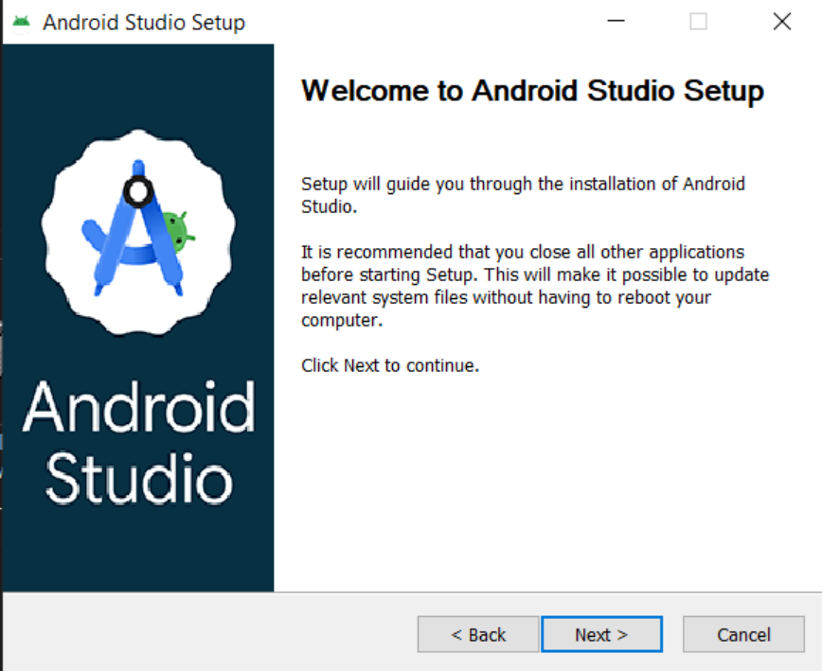
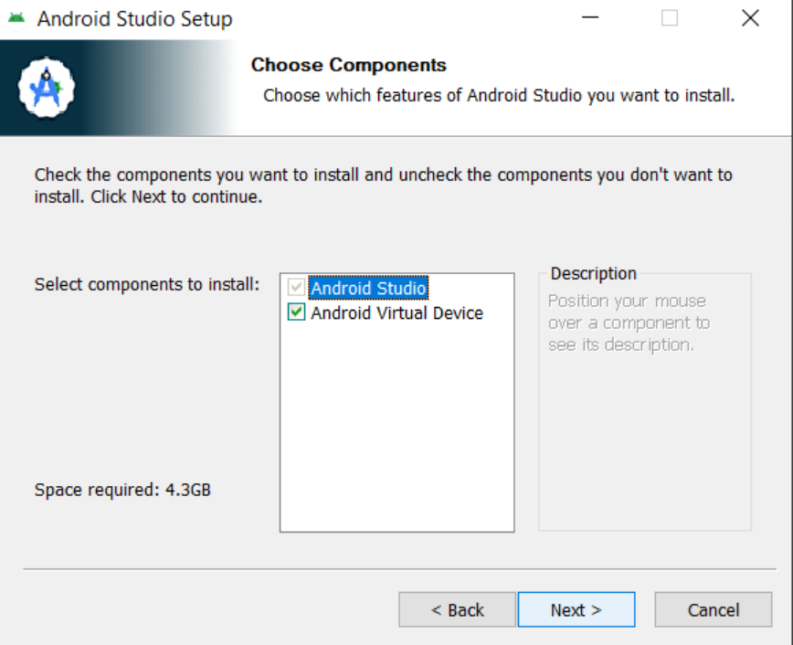
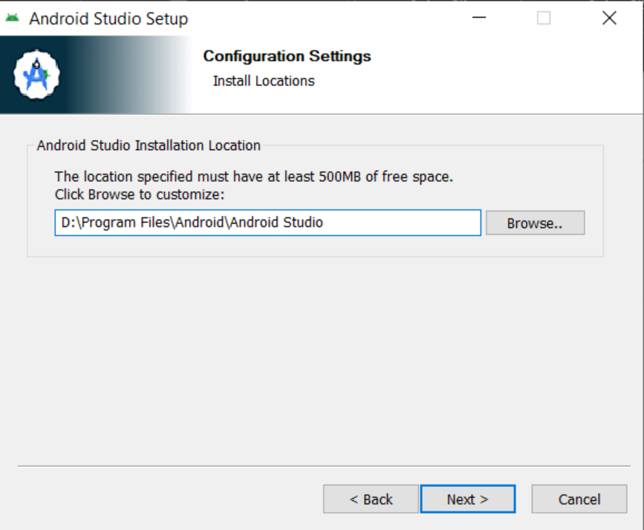
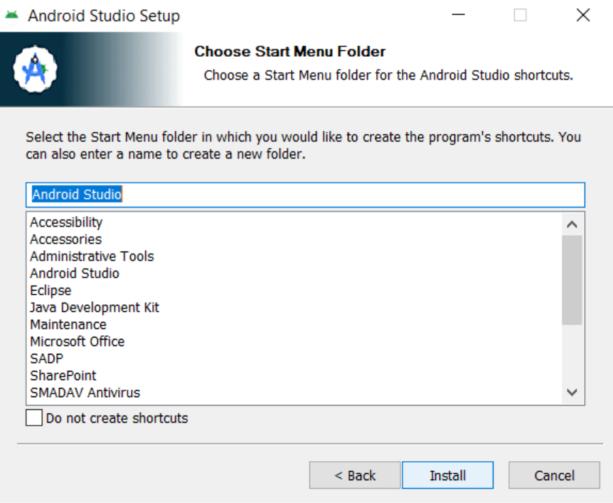
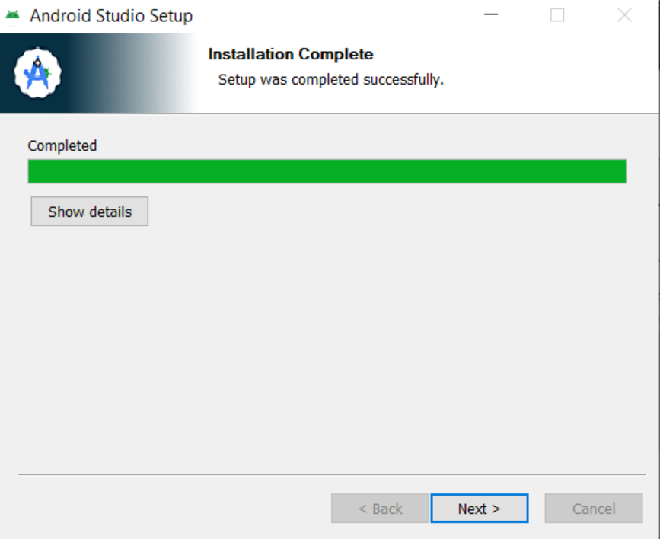
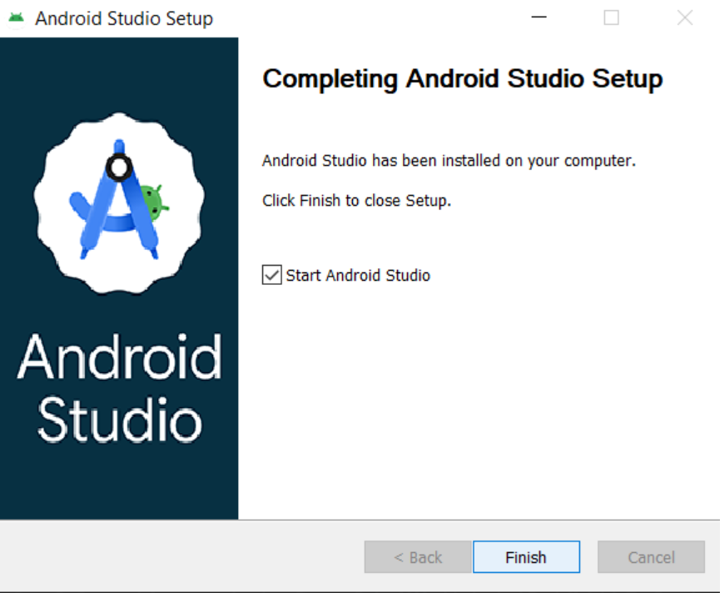

PERSONAL REFLECTION
Mobile development requires understanding both the technical tools and the business/ecosystem constraints. Cross-platform tools like Flutter lower the barrier to entry, but I still need to learn platform-specific details for production-ready apps. Mobile development requires understanding both the technical tools and the business/ecosystem constraints. Cross-platform tools like Flutter lower the barrier to entry, but I still need to learn platform-specific details for production-ready apps.

WEEK 2: MOBILE DEVELOPMENT ENVIRONMENT
Create a sign-up page
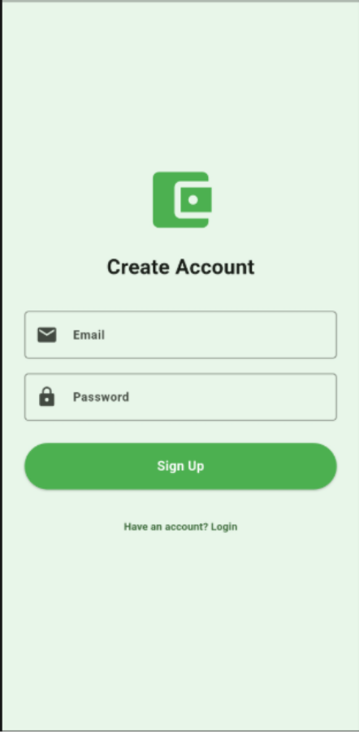

Login up page

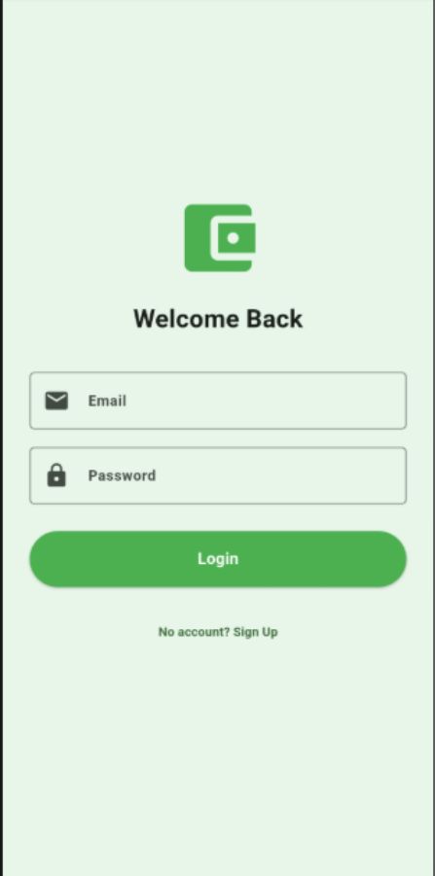

PERSONAL REFLECTION
Data integration is not just about code — it's about planning the data flow: where does data come from, where is it stored, how is it displayed, and how is it updated? Without this plan, the app becomes messy quickly.

WEEK 3: USER INTERFACE (UI) DEVELOPMENT
System giving alert on wrong email format
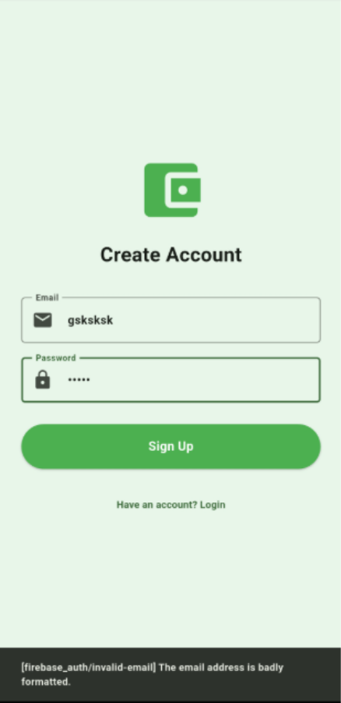

Dashboard screen
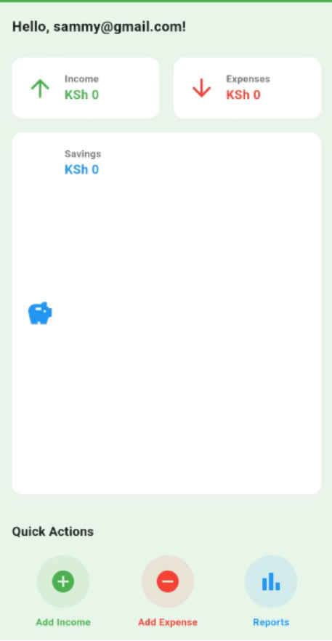

Functional add income button
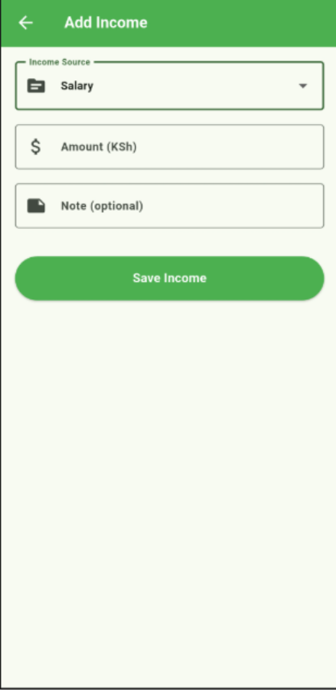

Functional add expense button
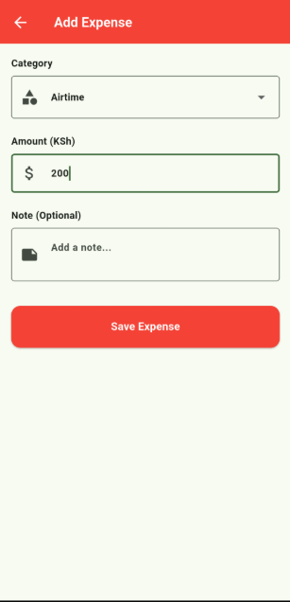

PERSONAL REFLECTION
Always test on at least one real device early in development. Design the navigation flow on paper before coding. Build responsive layouts from the start — retrofitting them later is painful.

WEEK 4: DATA MANAGEMENT
Sign up page
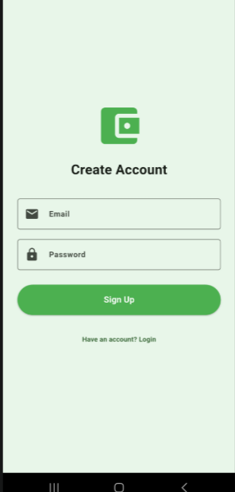

Login page
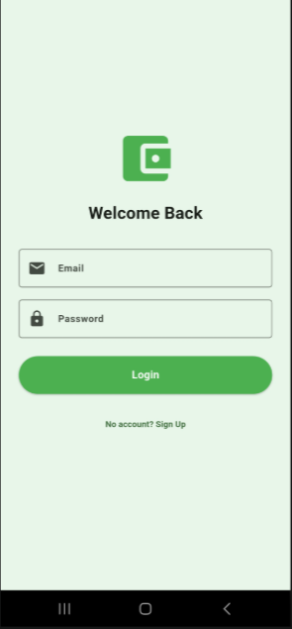

Add income
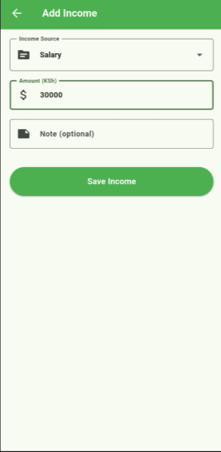

Add expense


Dashboard after addition
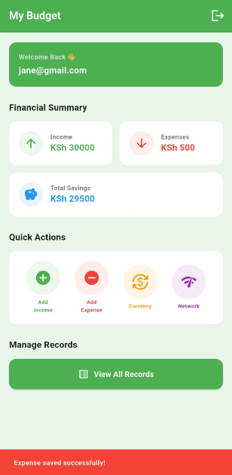

Records screen

Income
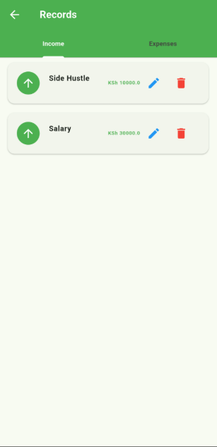

Expenses
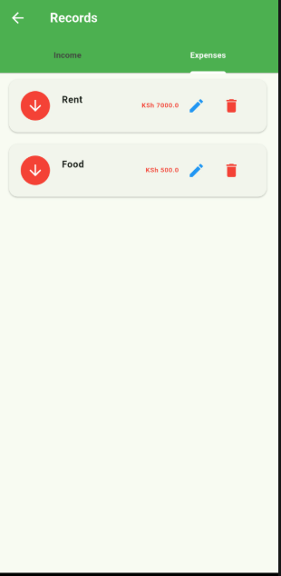

Edit record
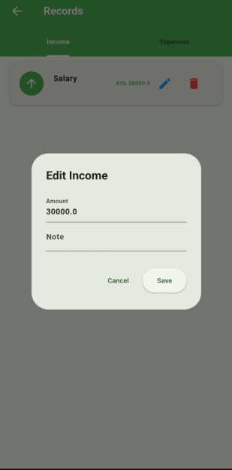

Firebase console
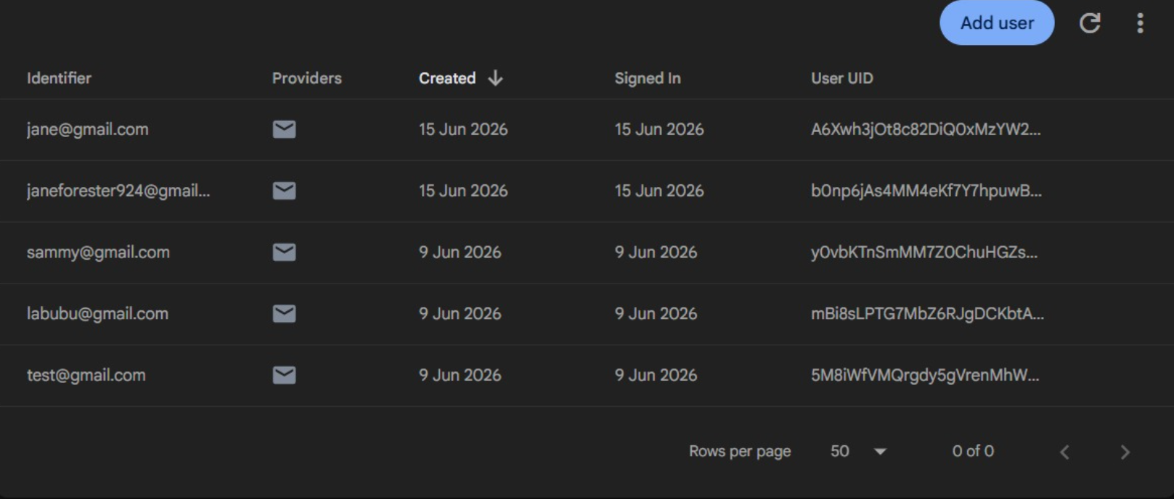
PERSONAL REFLECTION
Building the local storage feature opened my eyes to how apps store data offline. Implementing SQLite for structured records and Shared Preferences for settings taught me that not all data needs the cloud. Seeing records persist without internet felt like a real breakthrough in understanding app architecture.

CHAPTER 5: NETWORKING
Currency button


Currency screen – loading state
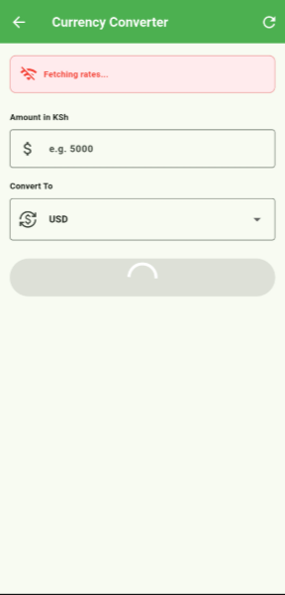

Currency screen – API connected
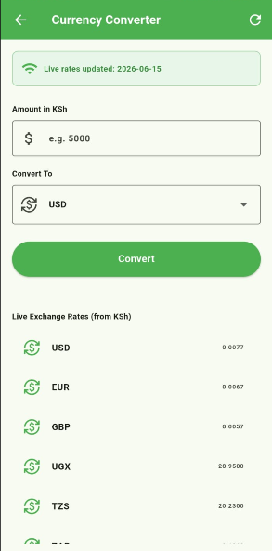

Currency conversion
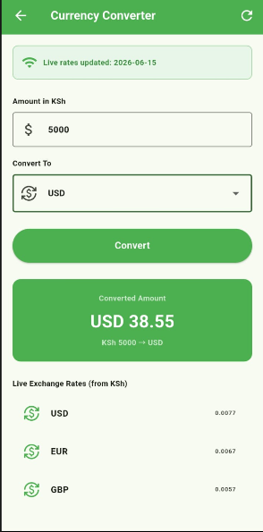

Live tables rate
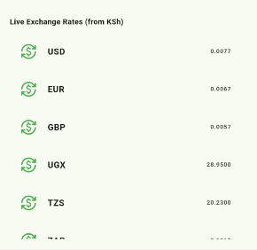

PERSONAL REFLECTION
Connecting my budget app to a live currency API made networking concepts click instantly. Writing actual GET requests and handling JSON responses asynchronously showed me how real-world apps communicate with servers. Watching live exchange rates appear on my phone felt incredibly rewarding.

CHAPTER 6: CONFIGURING INTERNET ACCESS
Network Status bar


Network status screen
Before testing conections
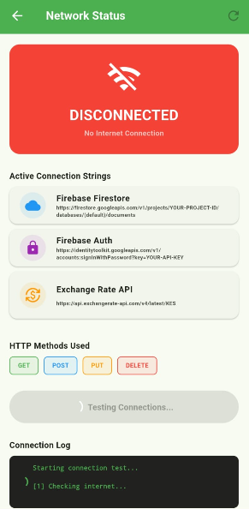

After testing connections
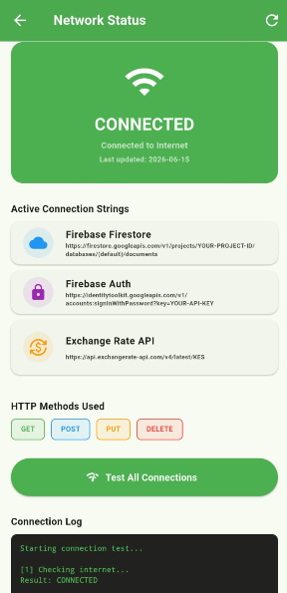

Connections strings
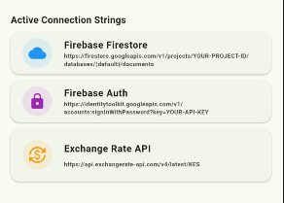
Connection strings (codes)
Network configuration
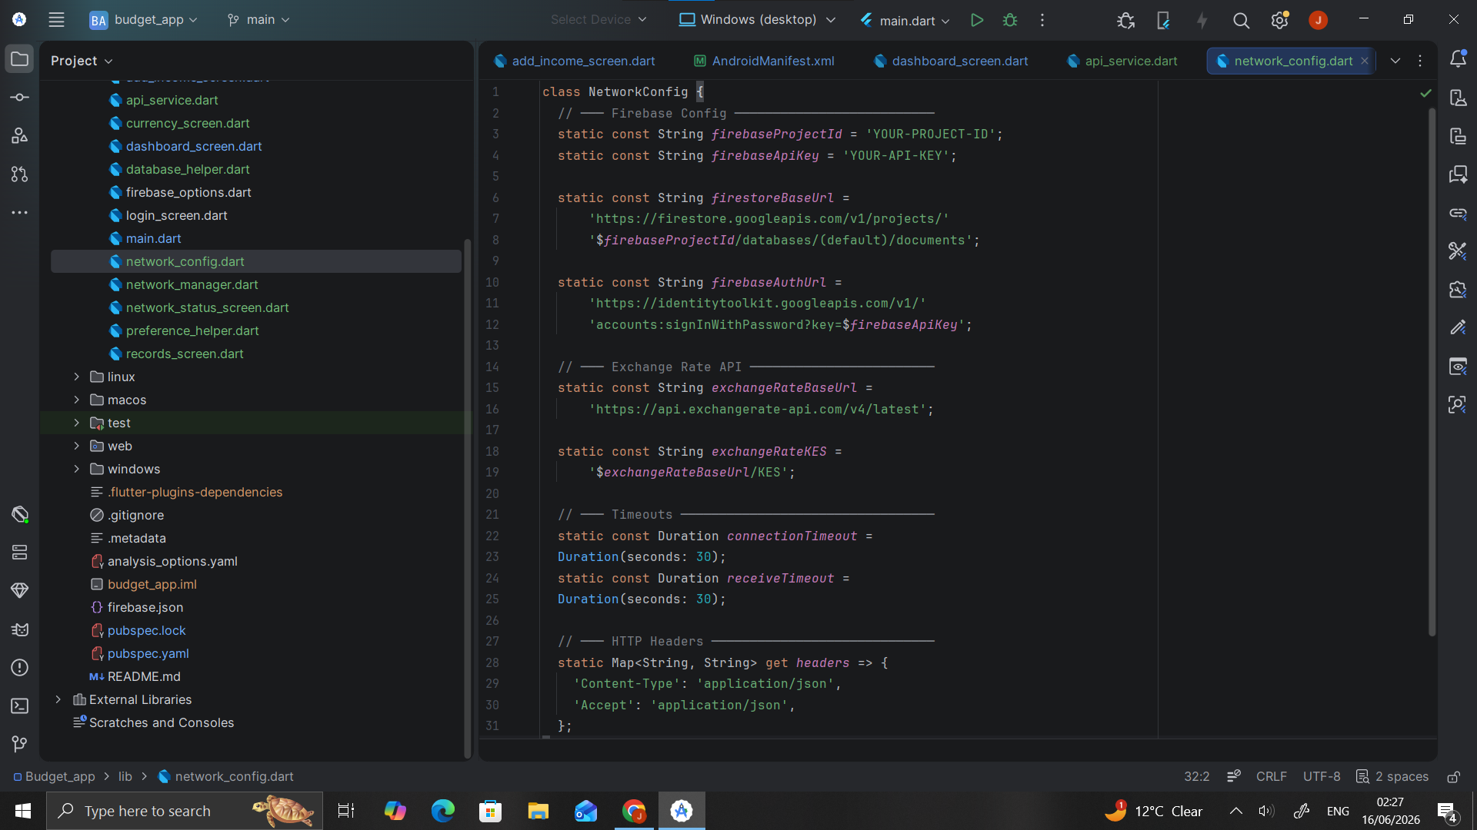
Network manager
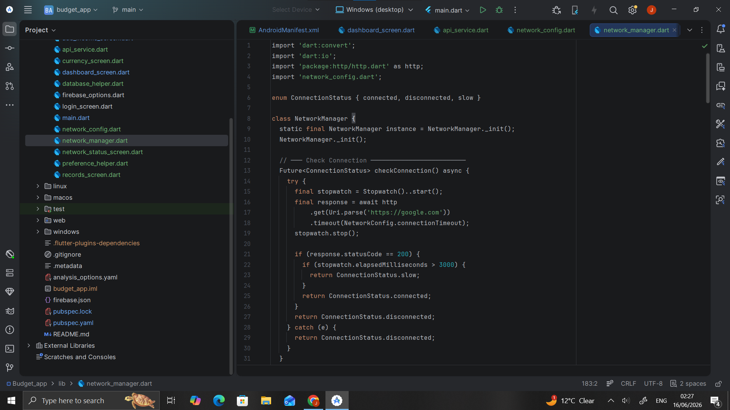
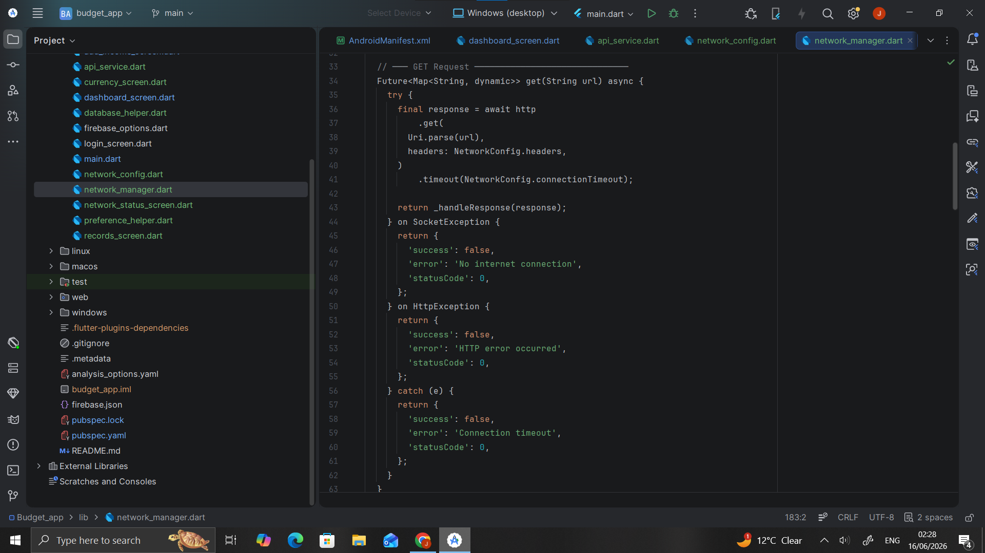
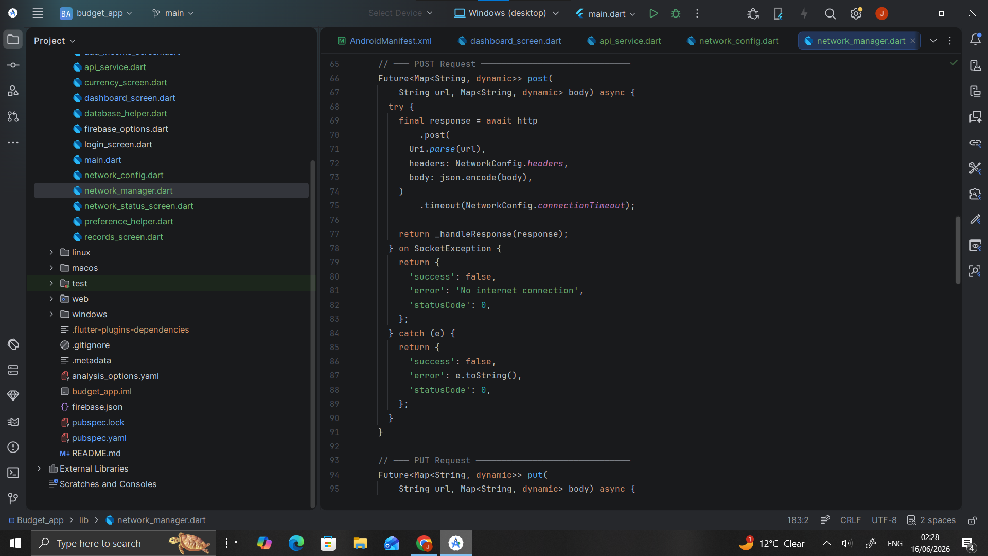
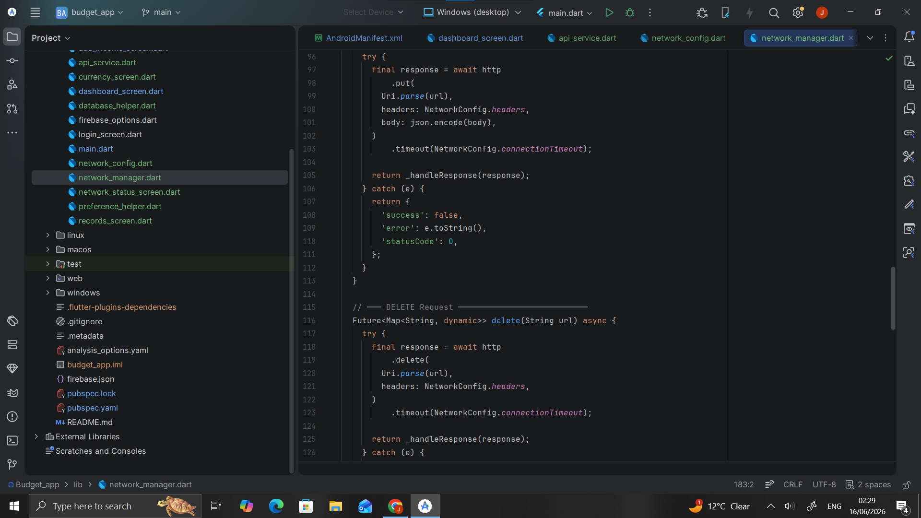
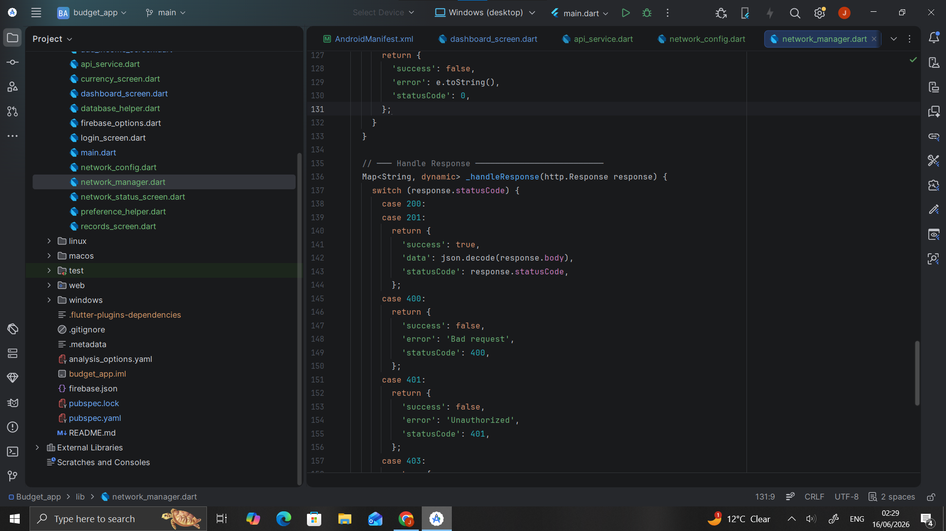
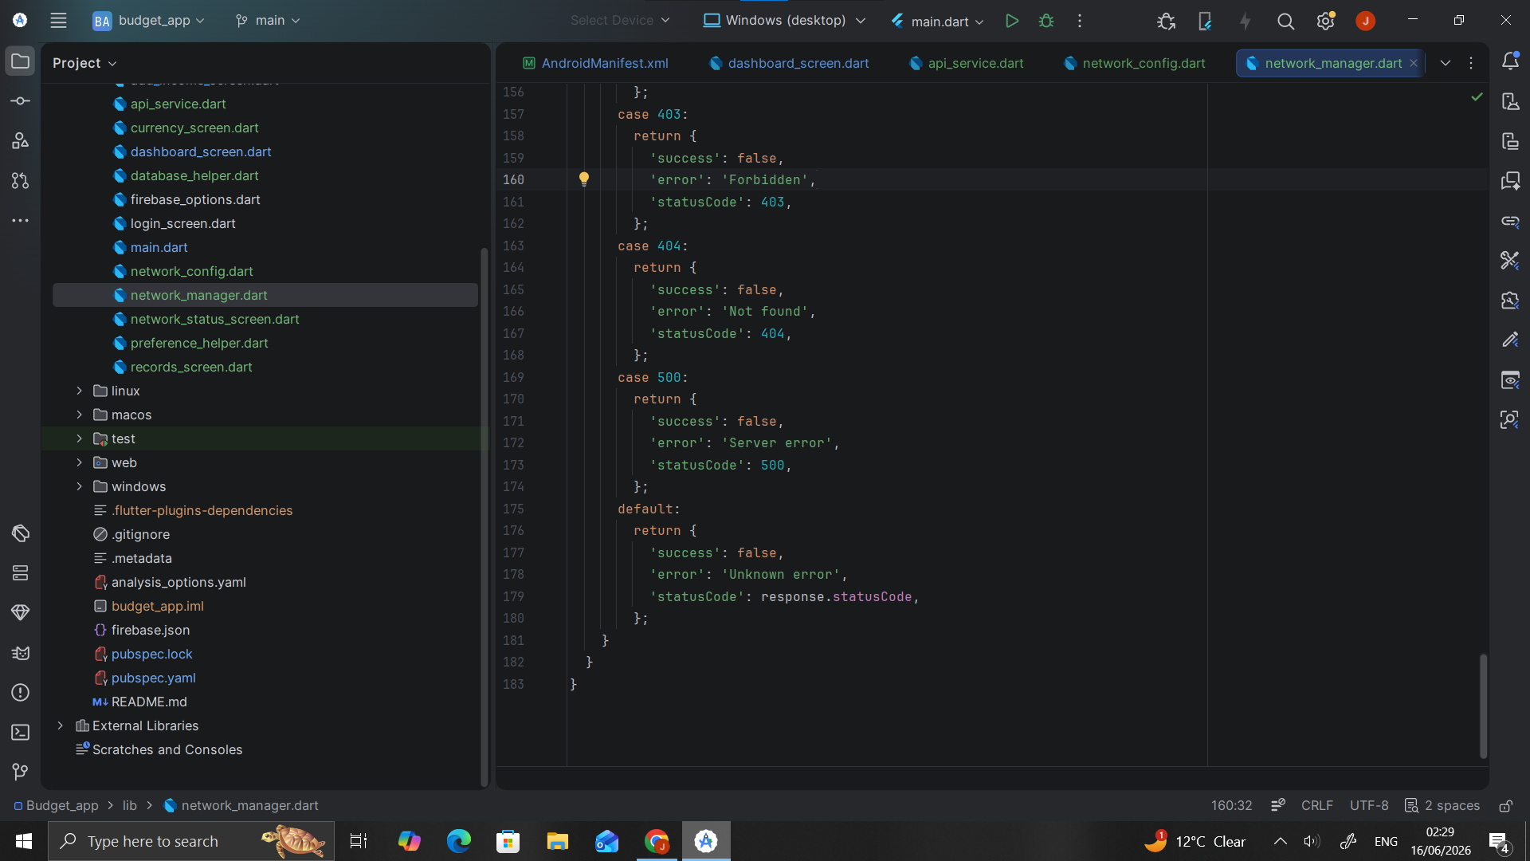
Network status screen
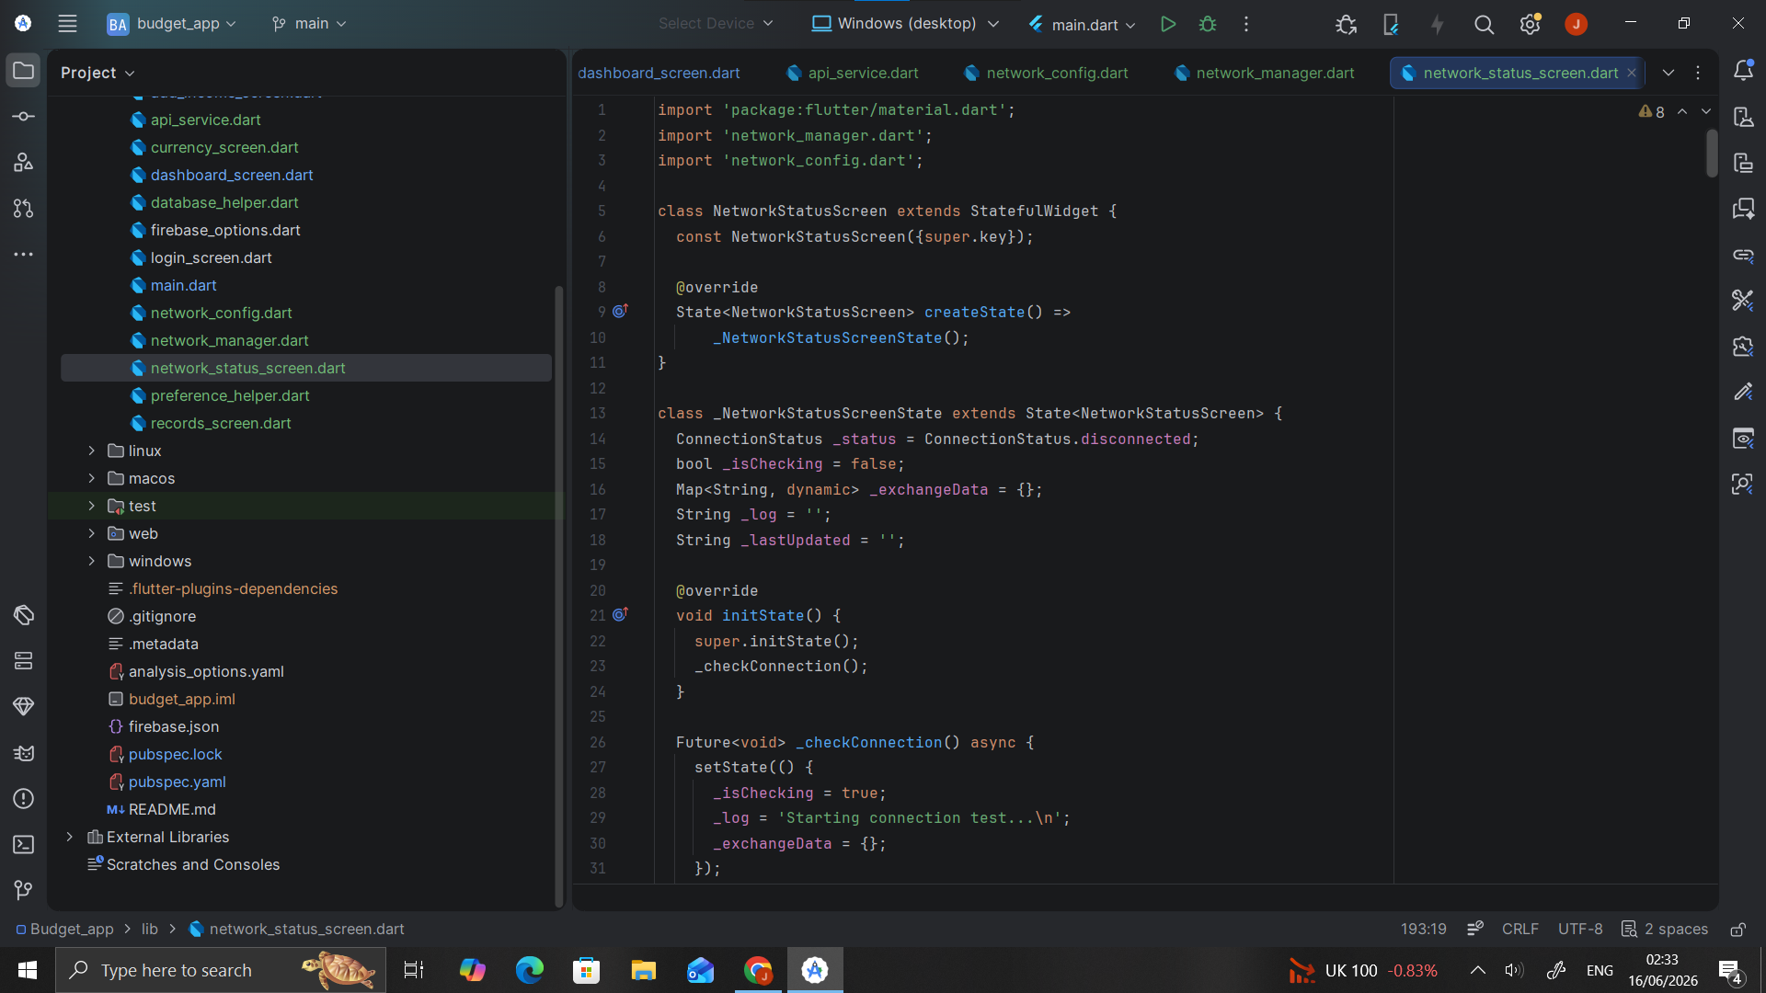
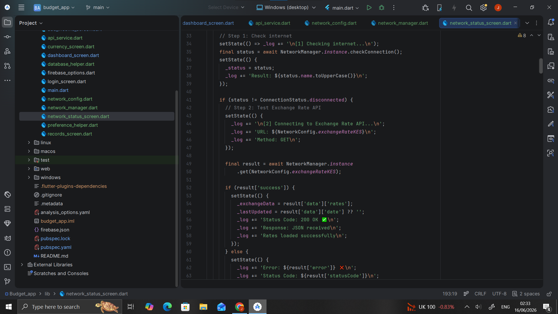
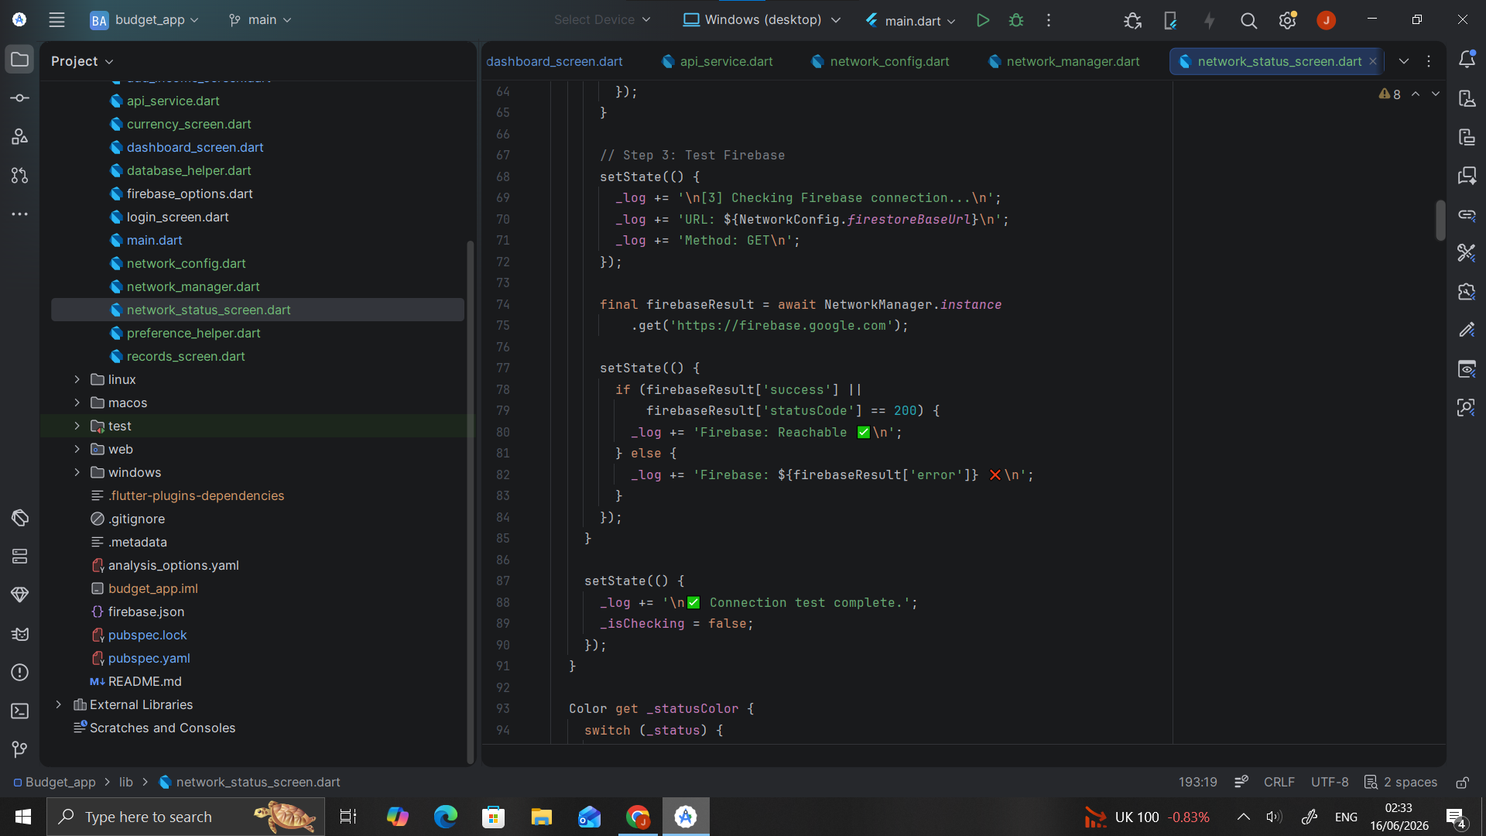
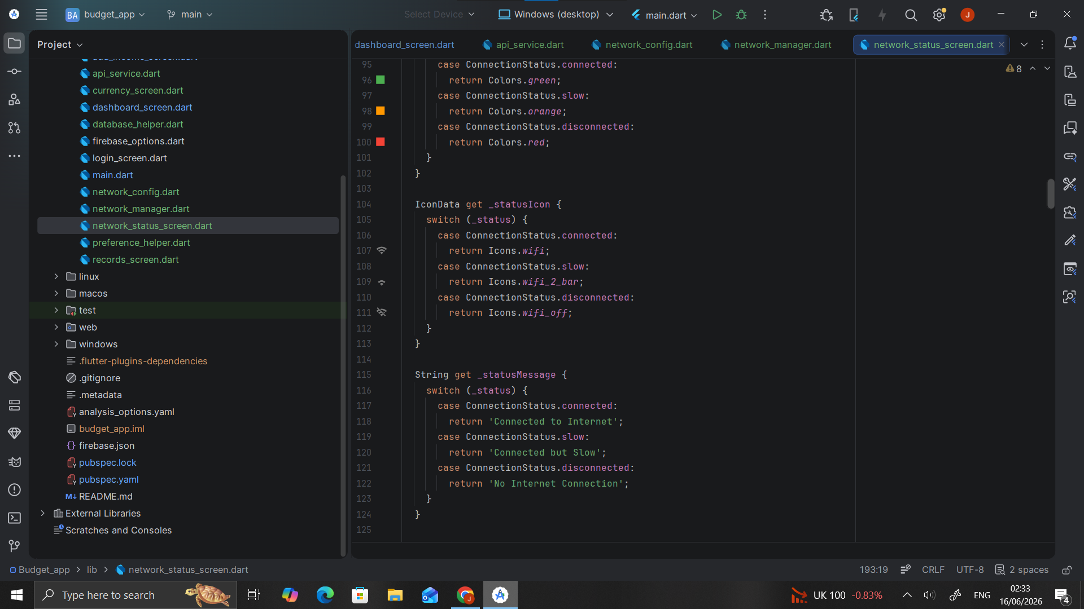
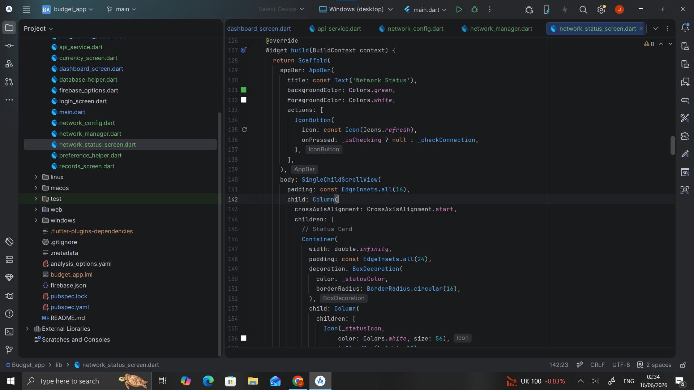
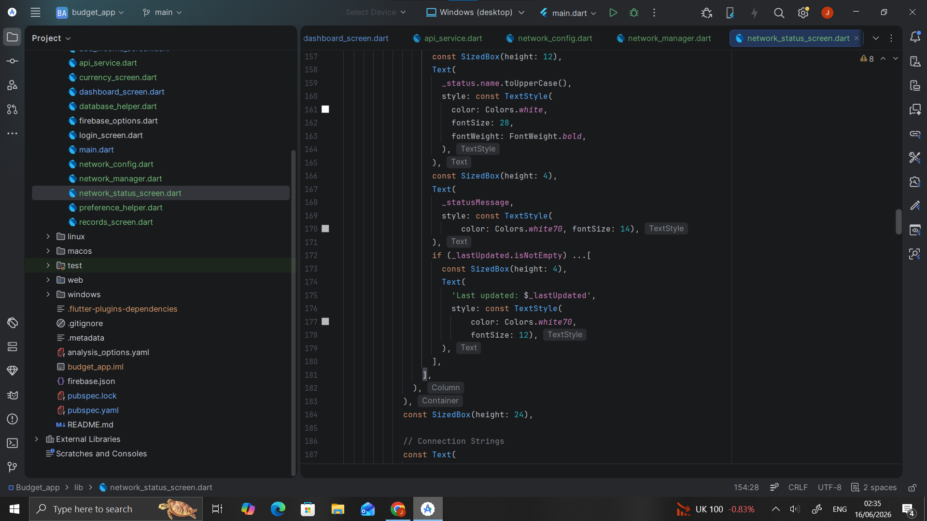
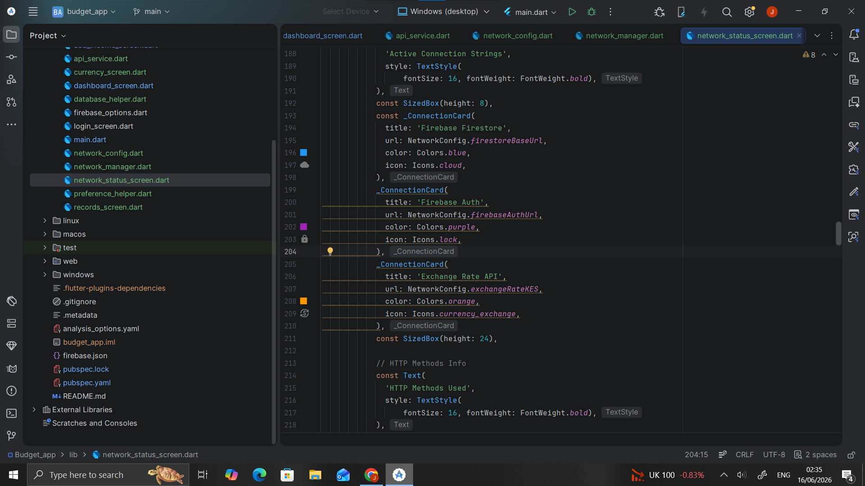
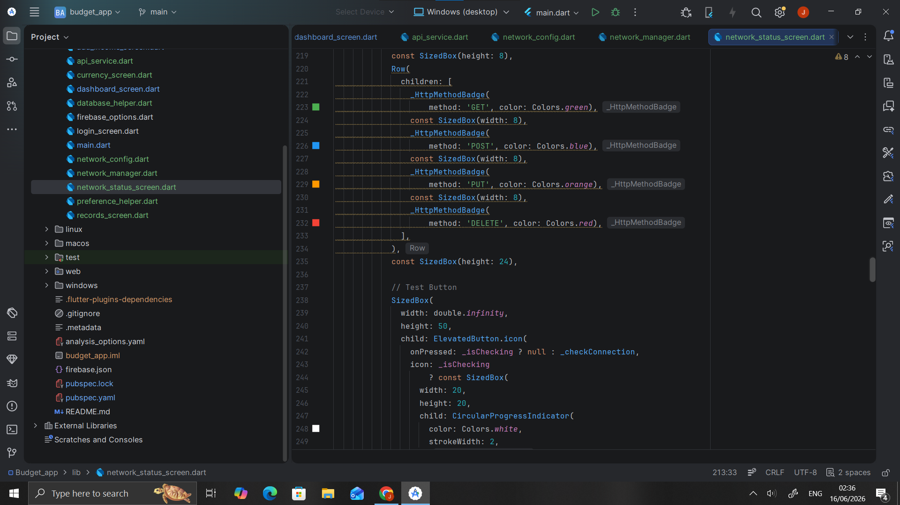
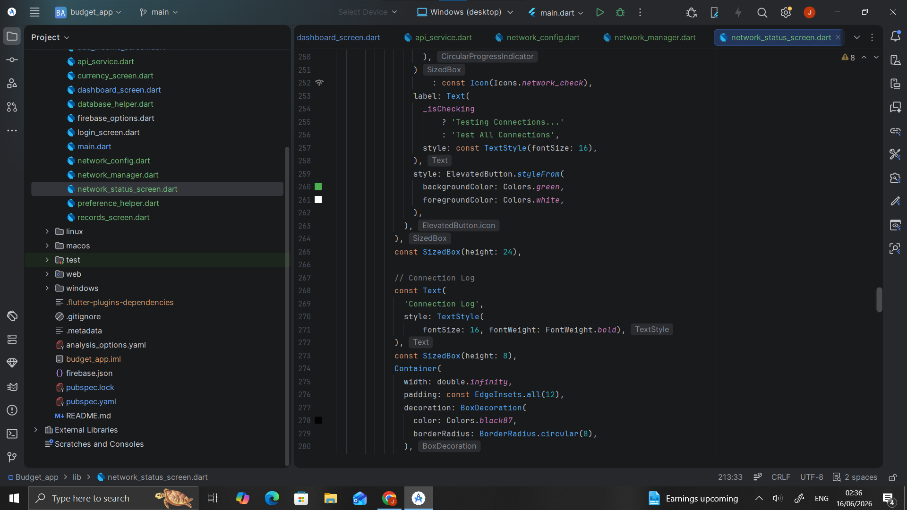
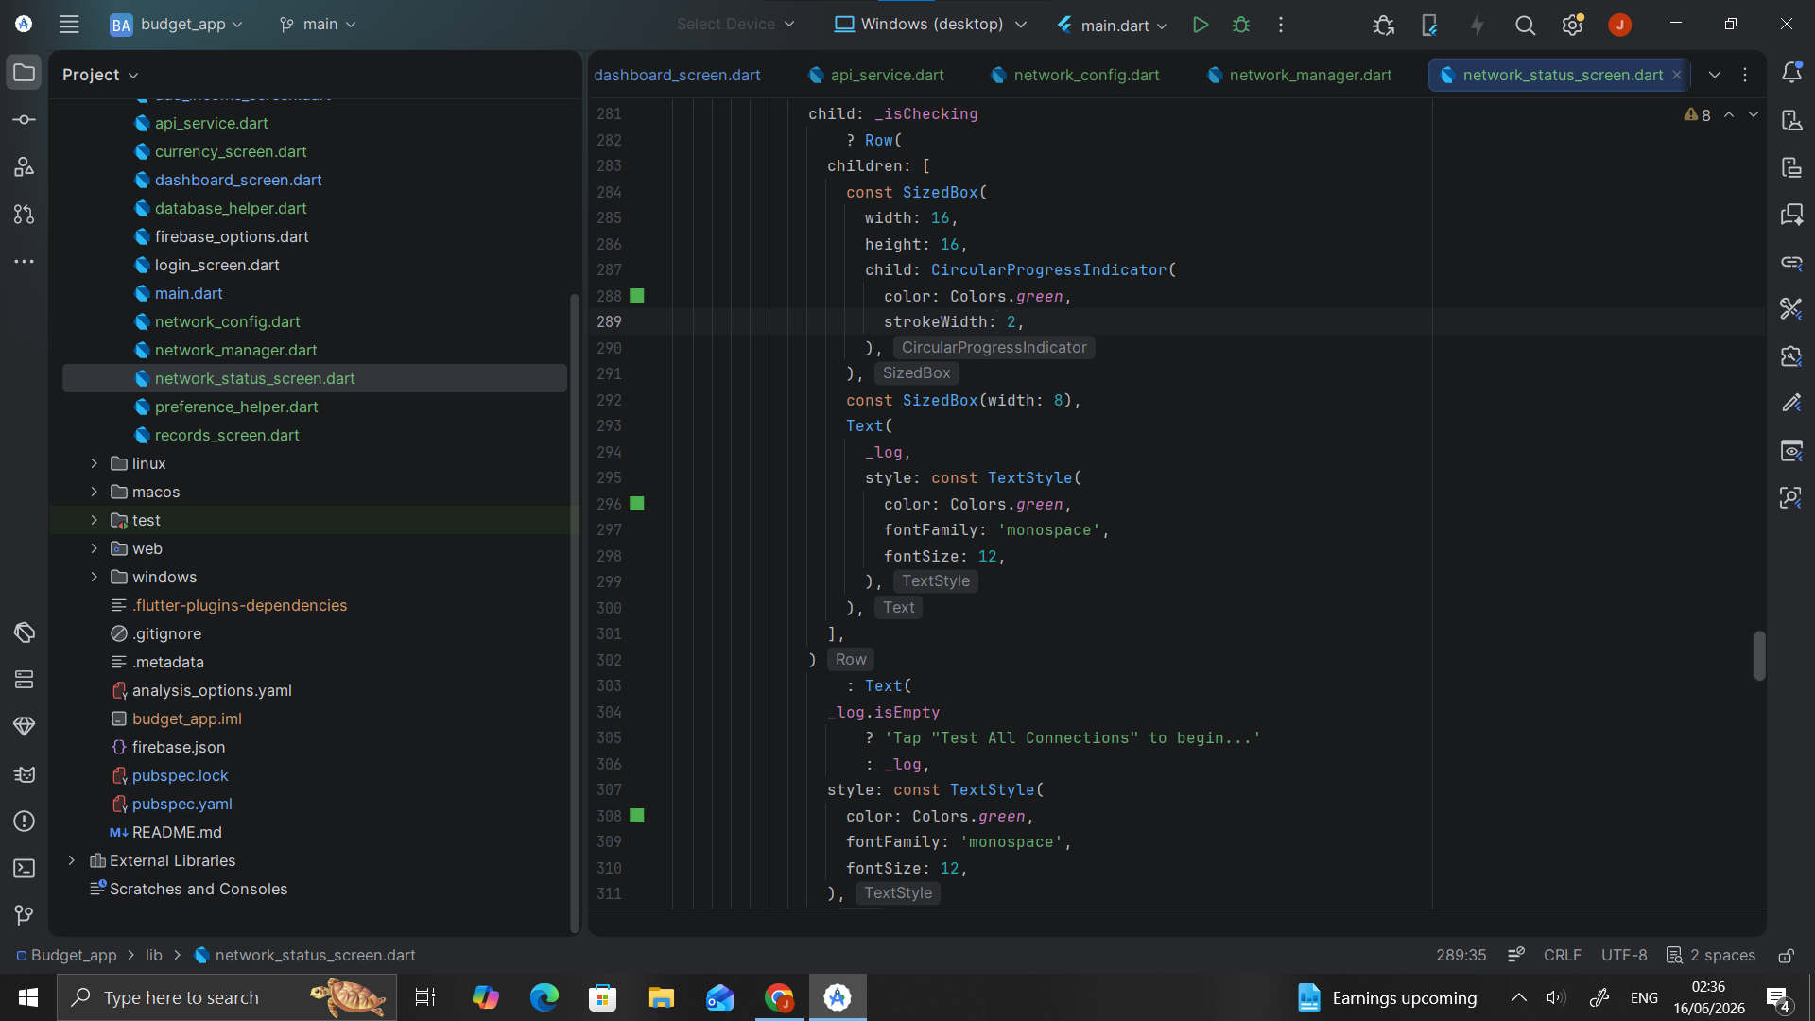
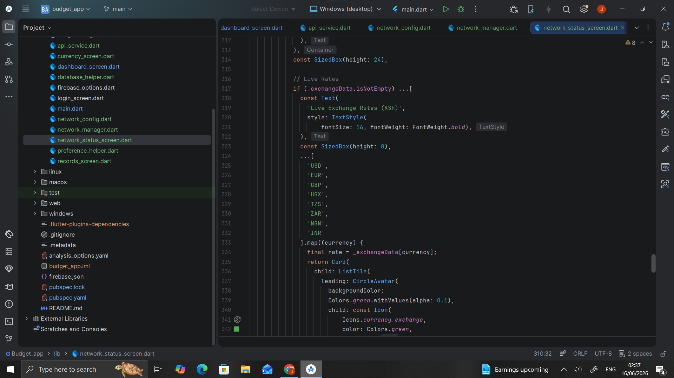
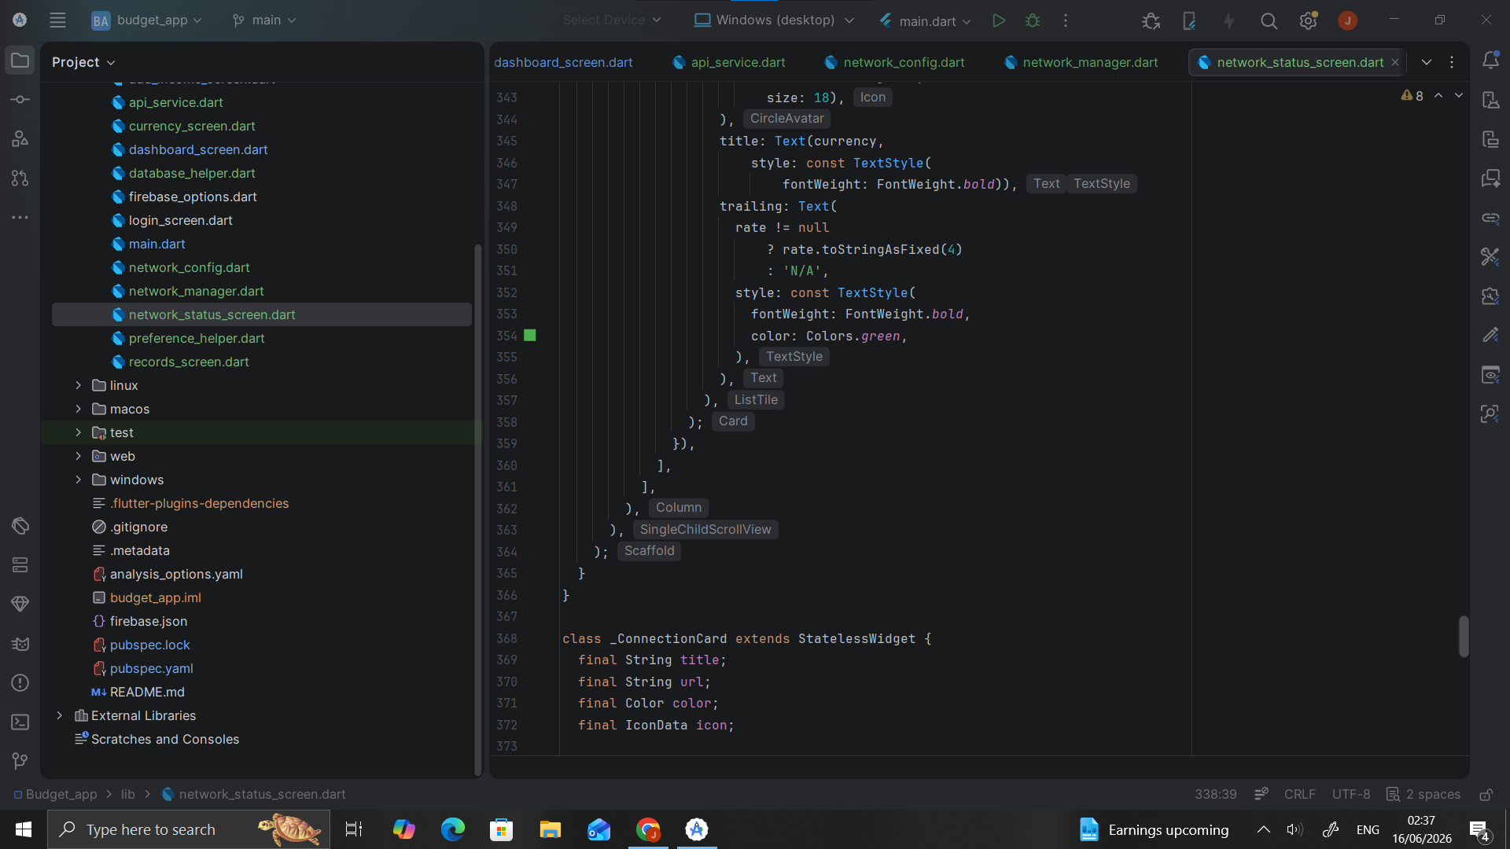
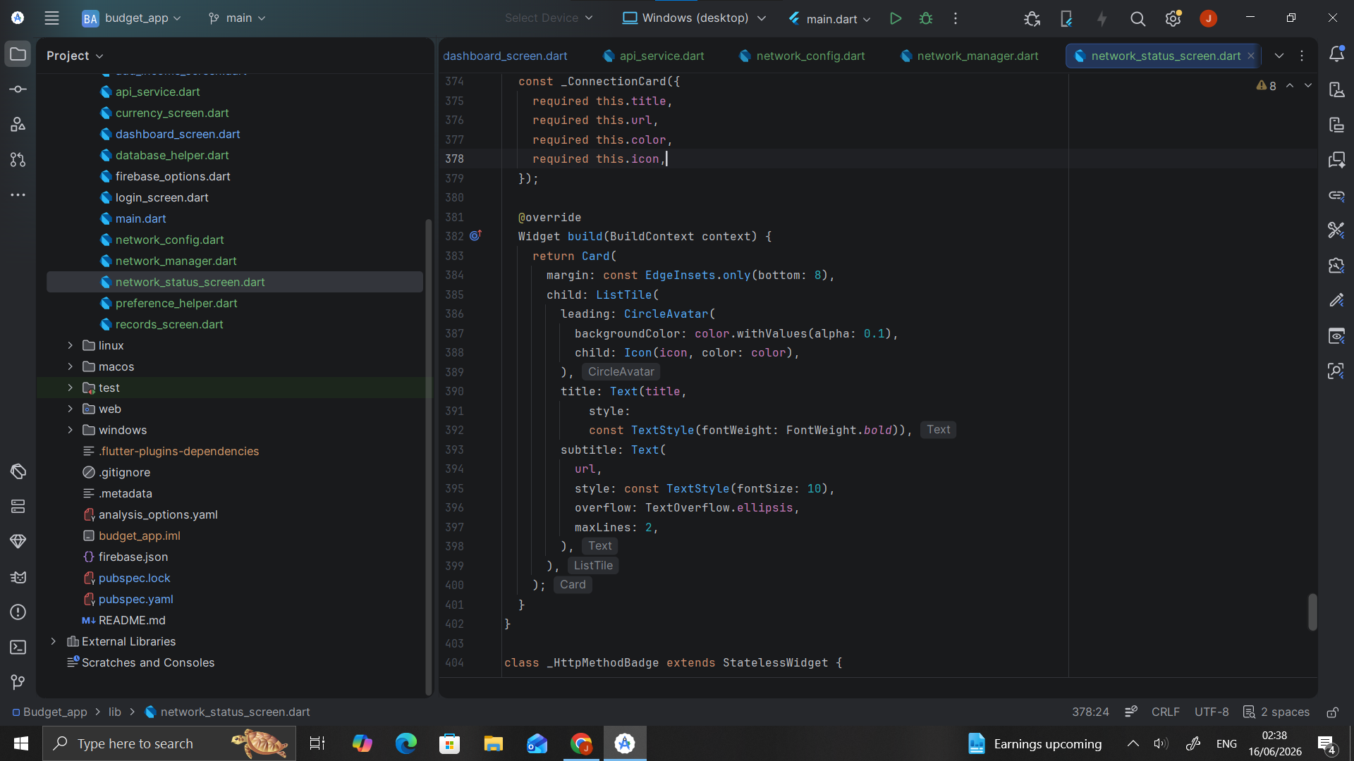
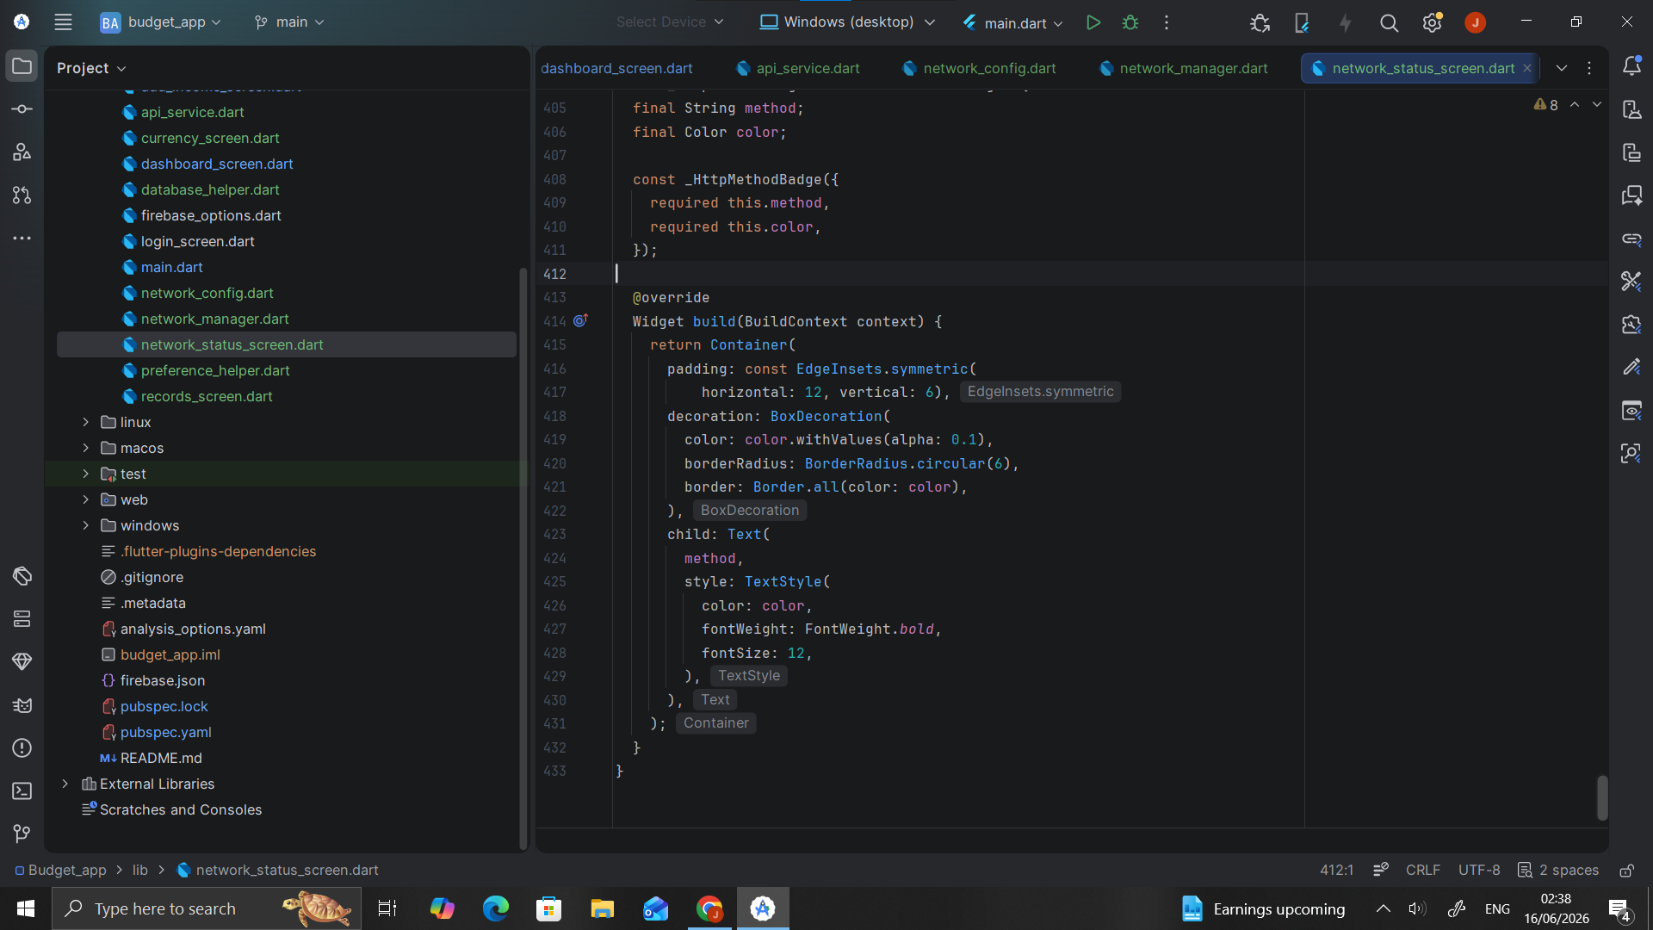
Connection log
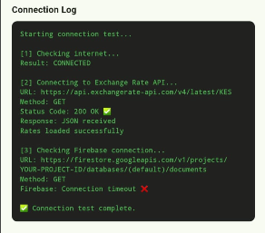

Error handling (WIFI turned off)
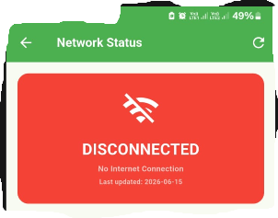

PERSONAL REFLECTION
Configuring internet permissions in my Flutter app taught me that mobile apps don't connect automatically without proper setup. Adding the internet permission to AndroidManifest.xml and building a network manager showed me how apps detect connection strength and handle failures gracefully, making the app reliable in real-world conditions.

WHY MY APP NEEDS NETWORKING
To send/receive data, sync with servers, load content, verify accounts, or show ads/updates.

WEEK 7: DATA STORAGE AND DATABASE INTEGRATION IN MOBILE APPLICATIONS

STORAGE METHOD COMPARISON
Storage Method | Advantages | Disadvantages
Shared Preferences | Simple, fast, no setup | Only key-value pairs, not for complex data
SQ Lite | Works offline, structured, supports queries | Single device only, no cloud sync
Firebase | Real-time, multi-device, automatic backup | Needs internet, costly at scale
Internal Storage | Private to app, good for files | Not queryable, not for structured data

SQLITE DATABASE DESIGN
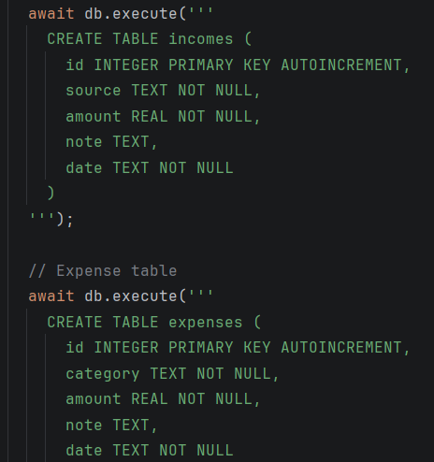

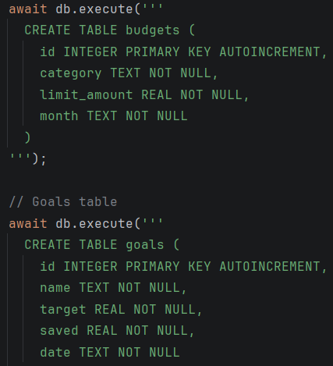

SHARED PREFERENCES
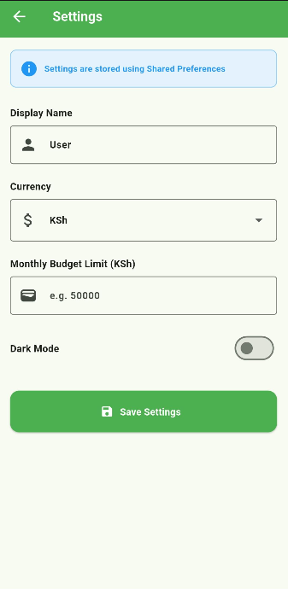

SHARED PREFERENCES SAVING
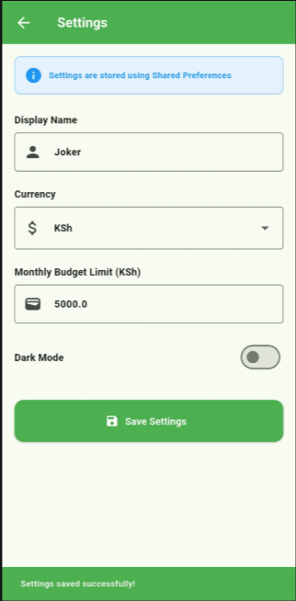

CRUD DEMOSTRATION
OPERATION CREATION AND SAVING
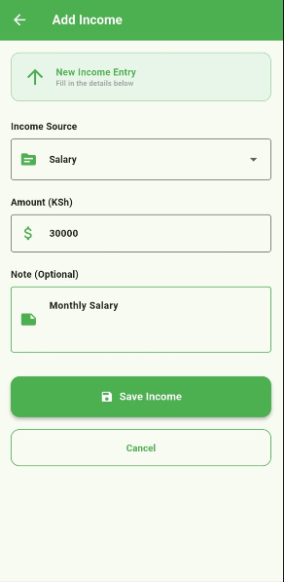

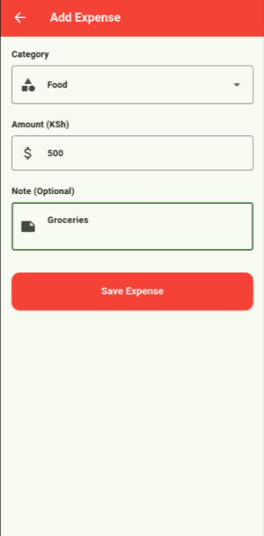

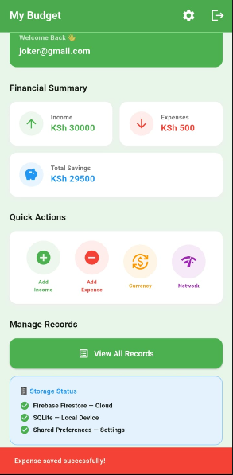

REAL-TIME DATA SAVED
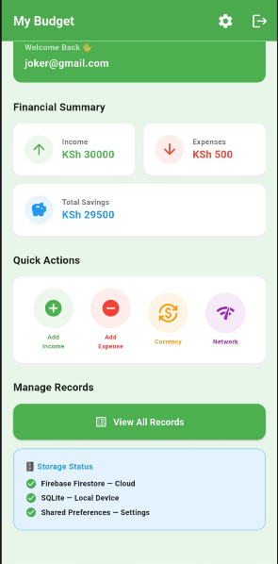

READ OPERATION

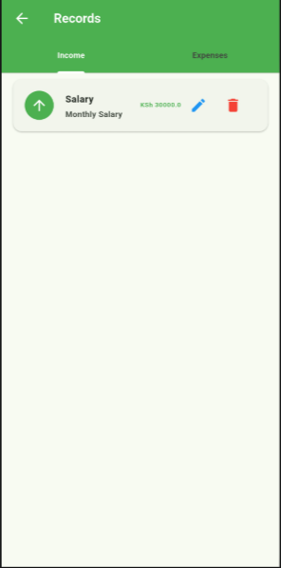

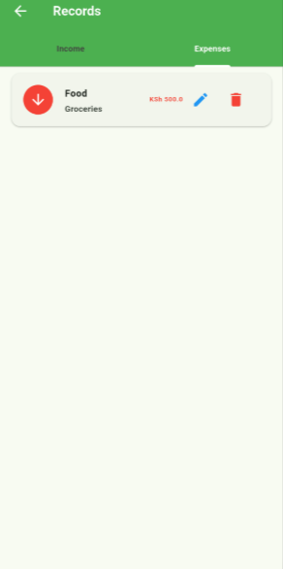

UPDATE OPERATION
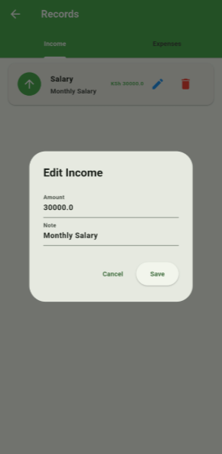

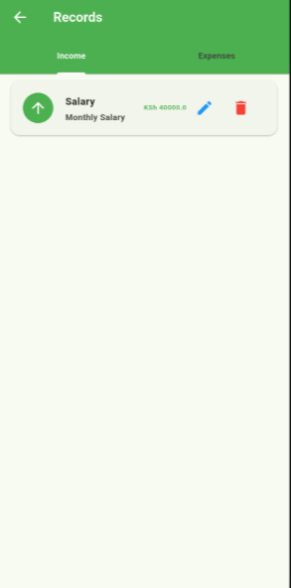

DELETE OPERATION
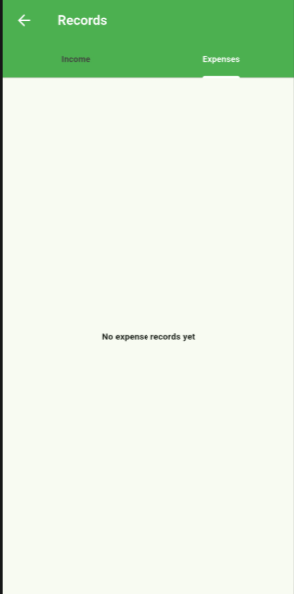

CLOUD STORAGE
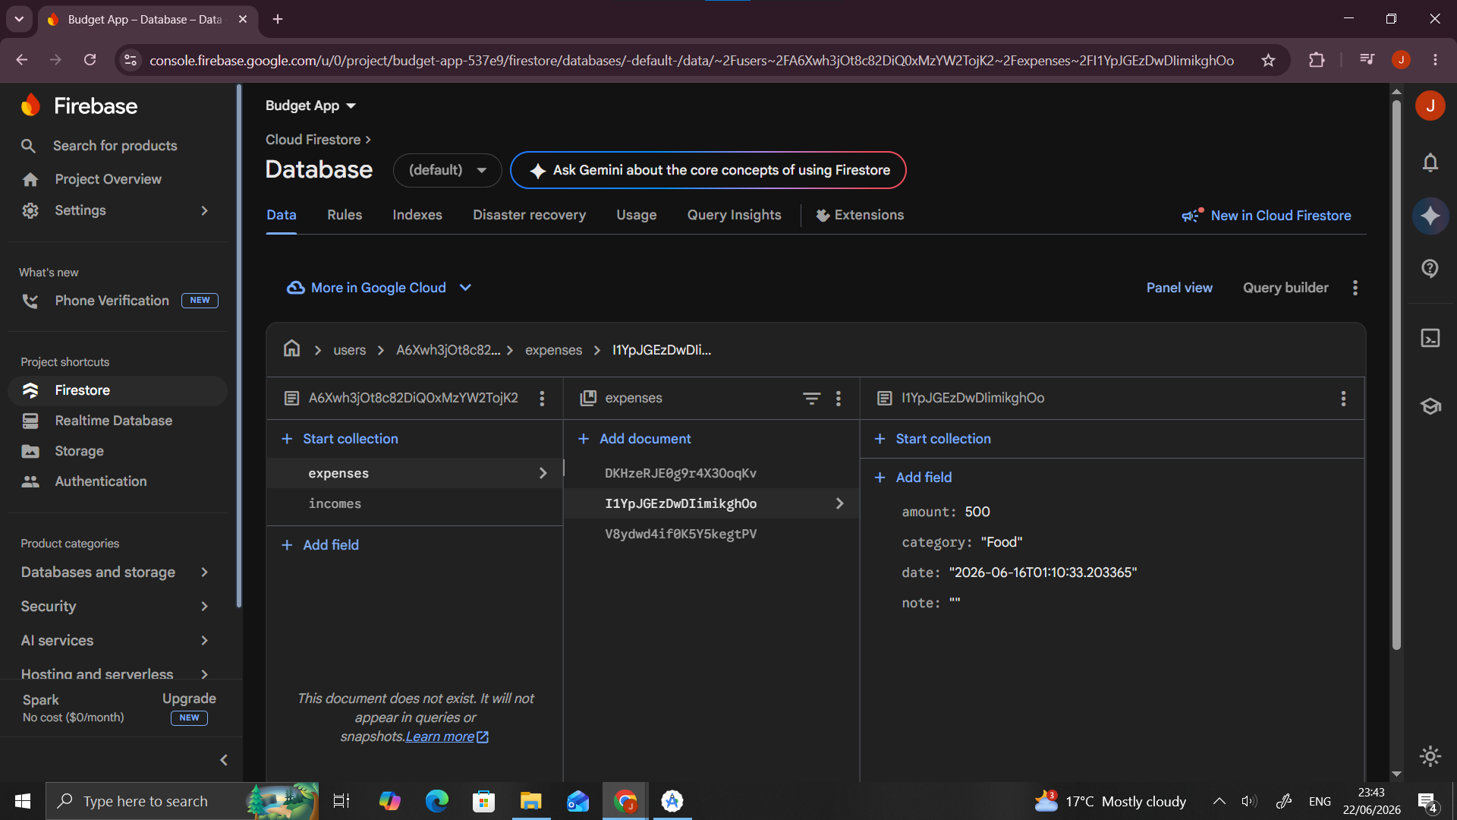
FIREBASE AUTHENTICATION
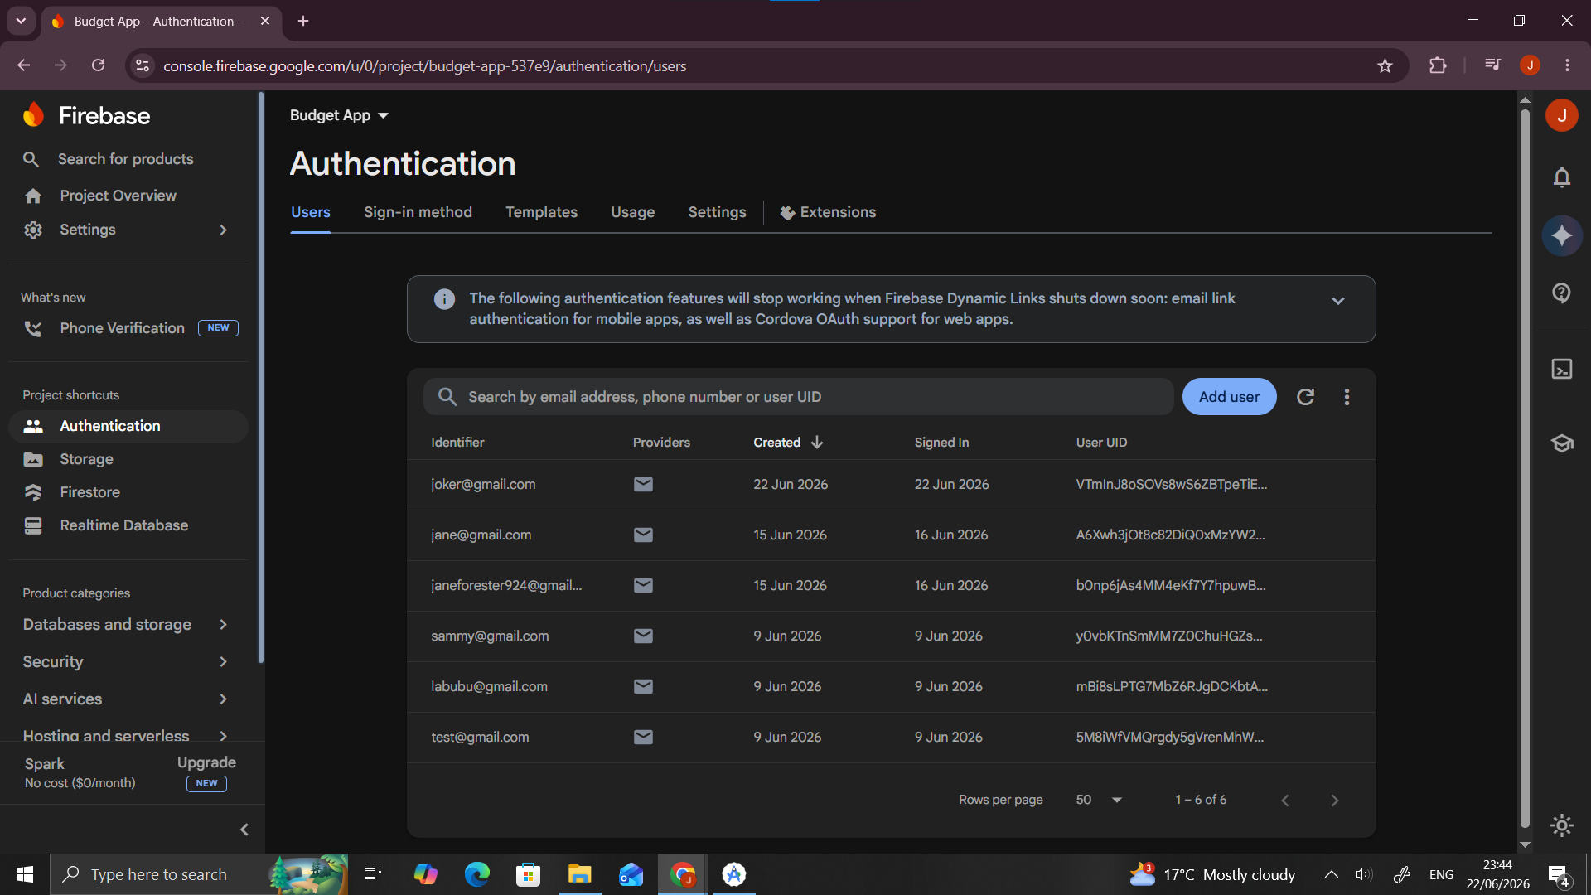
PERSONAL REFLECTION
Implementing SQLite, Shared Preferences, and Firebase together revealed how different storage methods serve different purposes. Building CRUD operations from scratch in database_helper.dart deepened my understanding of how data persists locally while Firebase handles cloud synchronization, making the budget app functional both online and offline.

WEEK 8: HANDLING USER INPUT AND EVENTS
LOGIN SCREEN — KEYBOARD + VALIDATION
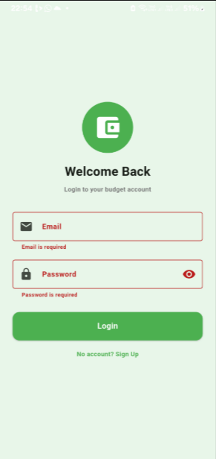

CHECKING IF THE EMAIL AND PASSWORDS ENTERED ARE VALID
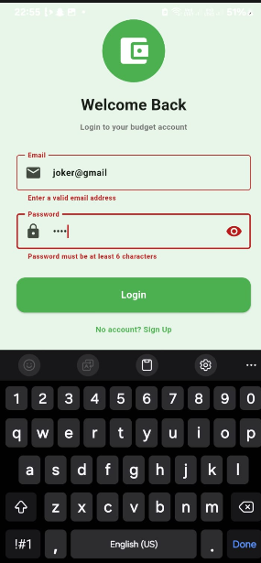

IF VALID- DIRECTS TO DASHBOARD
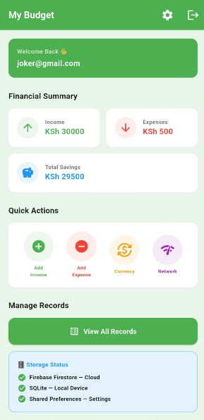

ADD INCOME — KEYBOARD INPUT
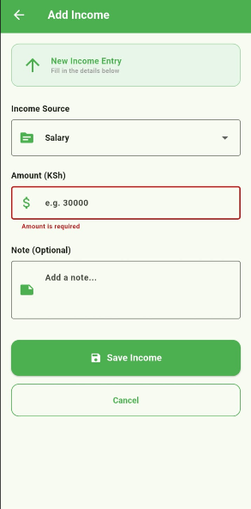

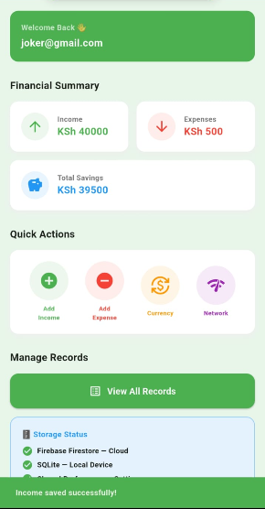

ADD EXPENSE — KEYBOARD INPUT
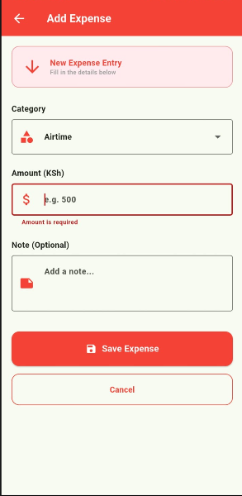

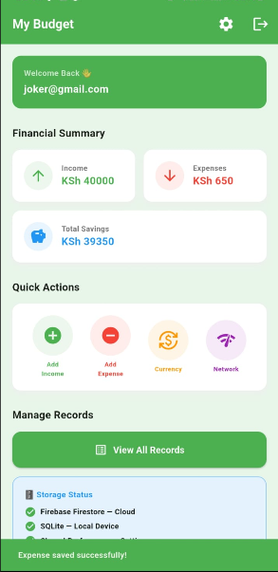

RECORDS SCREEN — TOUCH GESTURES
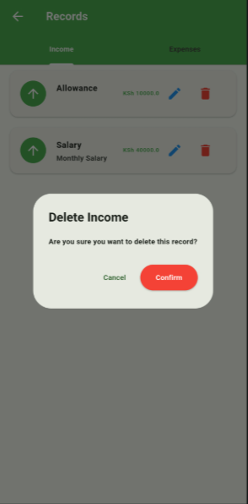

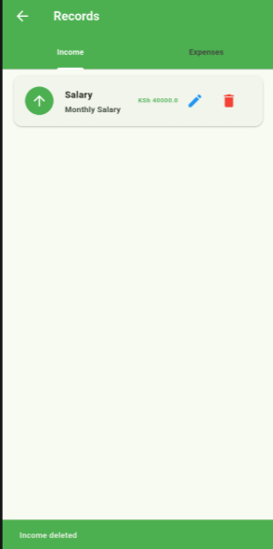

PERSONAL REFLECTION
Week 8 transformed my understanding of how apps respond to users. Implementing touch gestures and keyboard validation using OOP classes like InputHandler and EventHandler showed me that clean event-driven code makes apps feel responsive and professional. Organizing functionality into reusable classes improved my overall code structure significantly.

WEEK 9:
DEVICE FEATURES
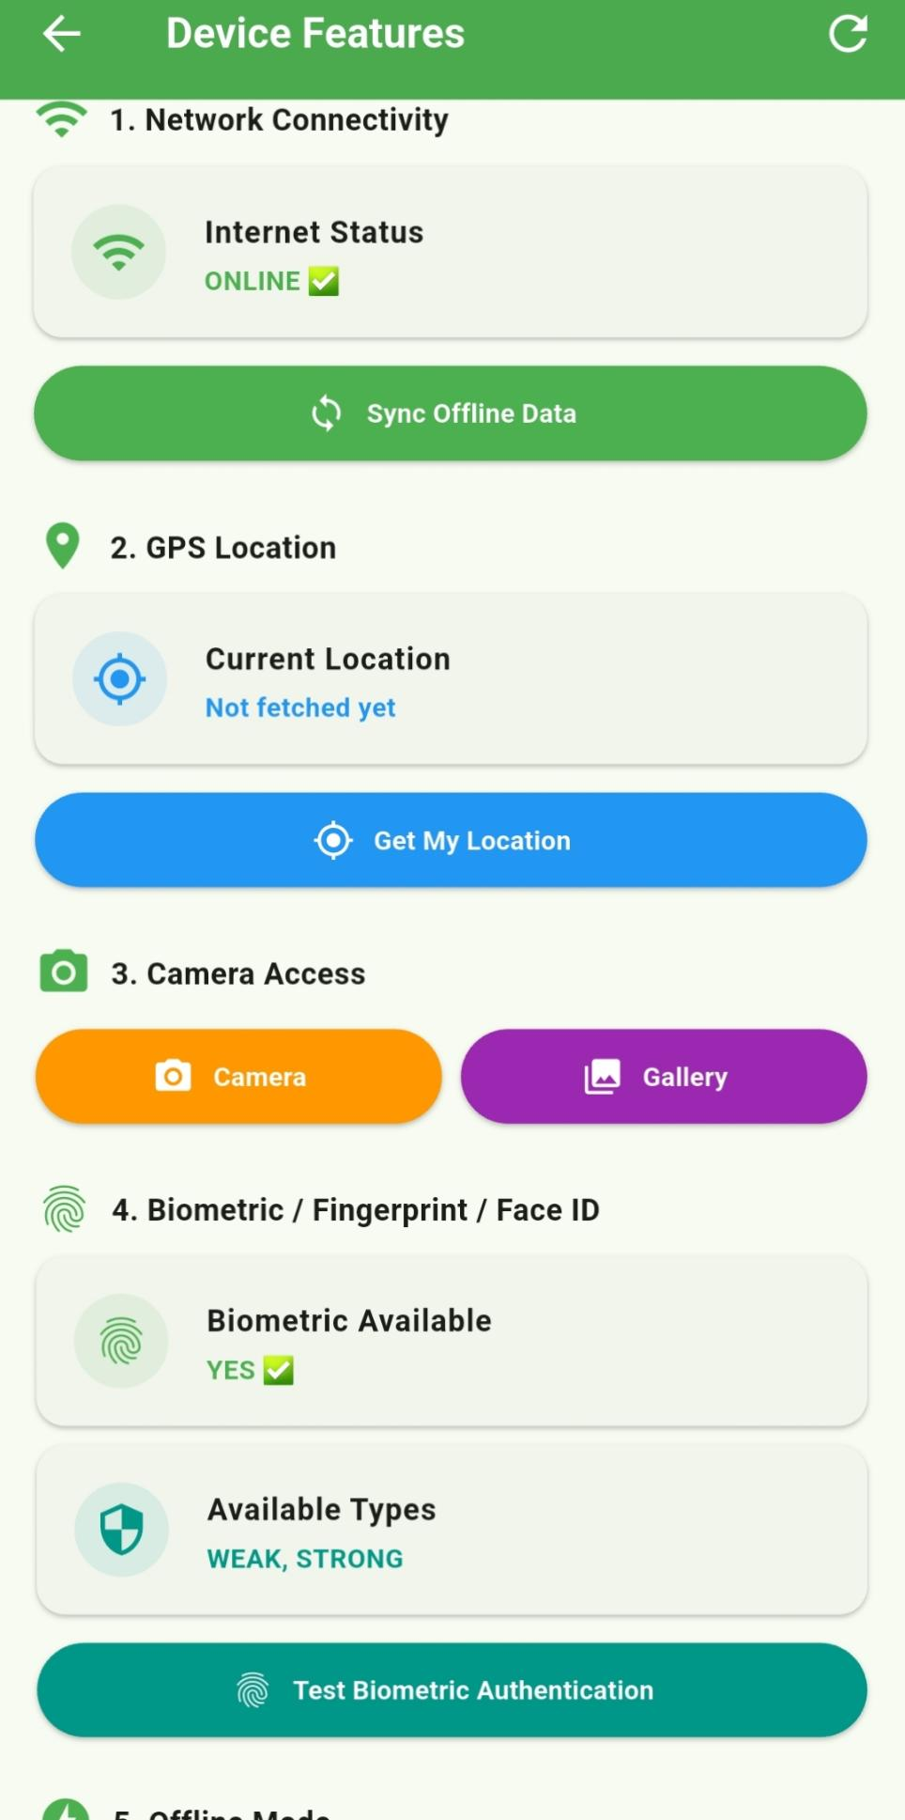
CAMERA ACCESS PERMISSION REQUEST
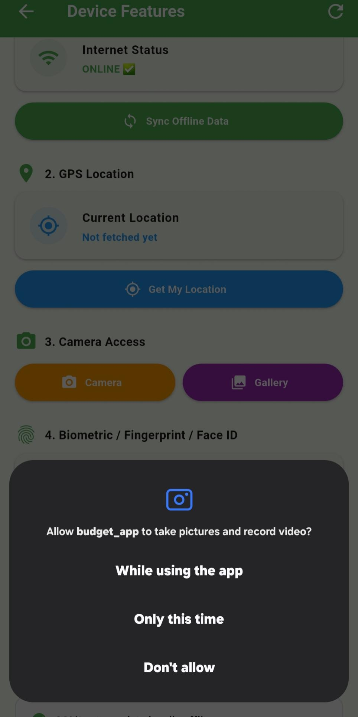

IMAGE TAKEN BY CAMERA DISPLAYED
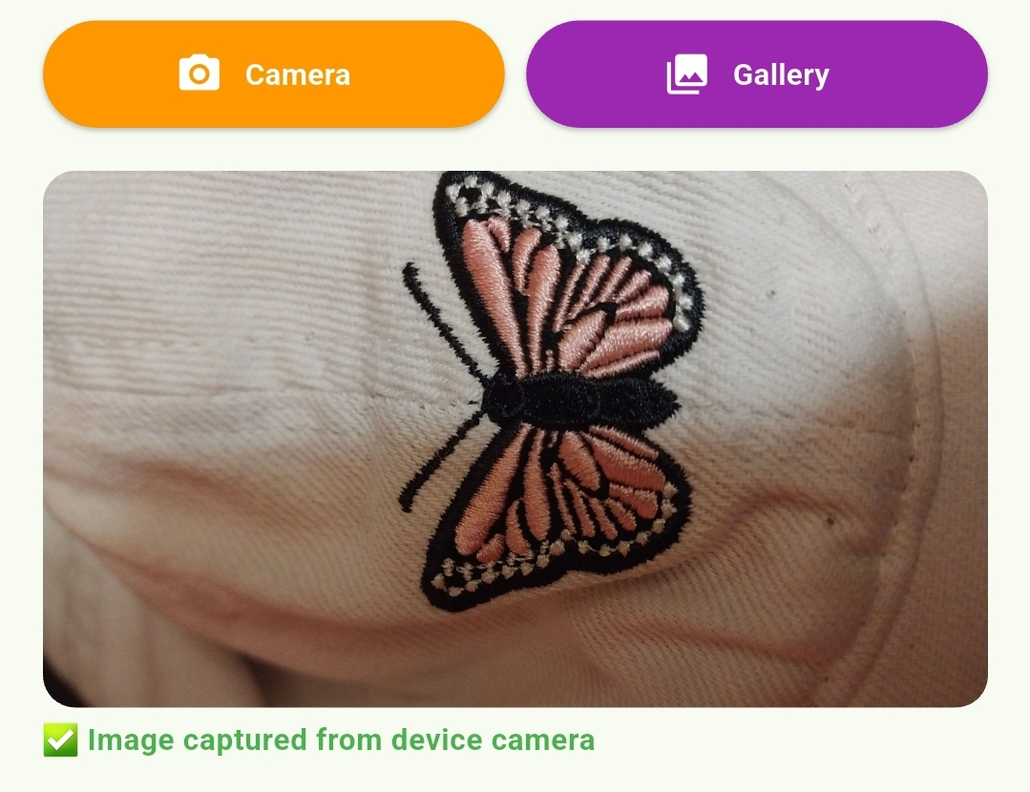

IMAGE FROM GALLERY DISPLAYED
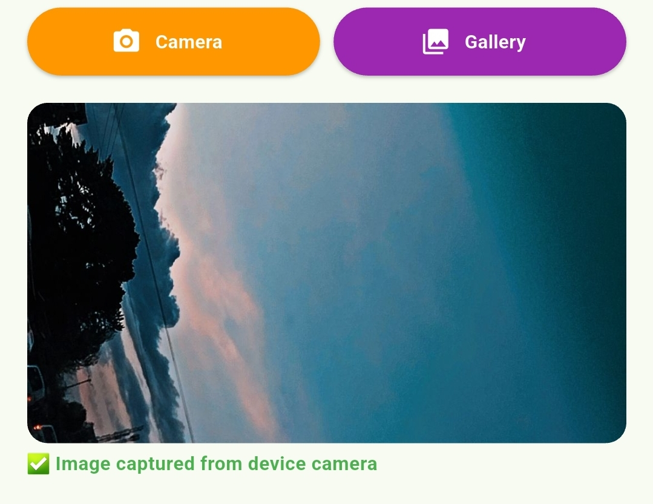

GPS LOCATION PERMISSION REQUEST
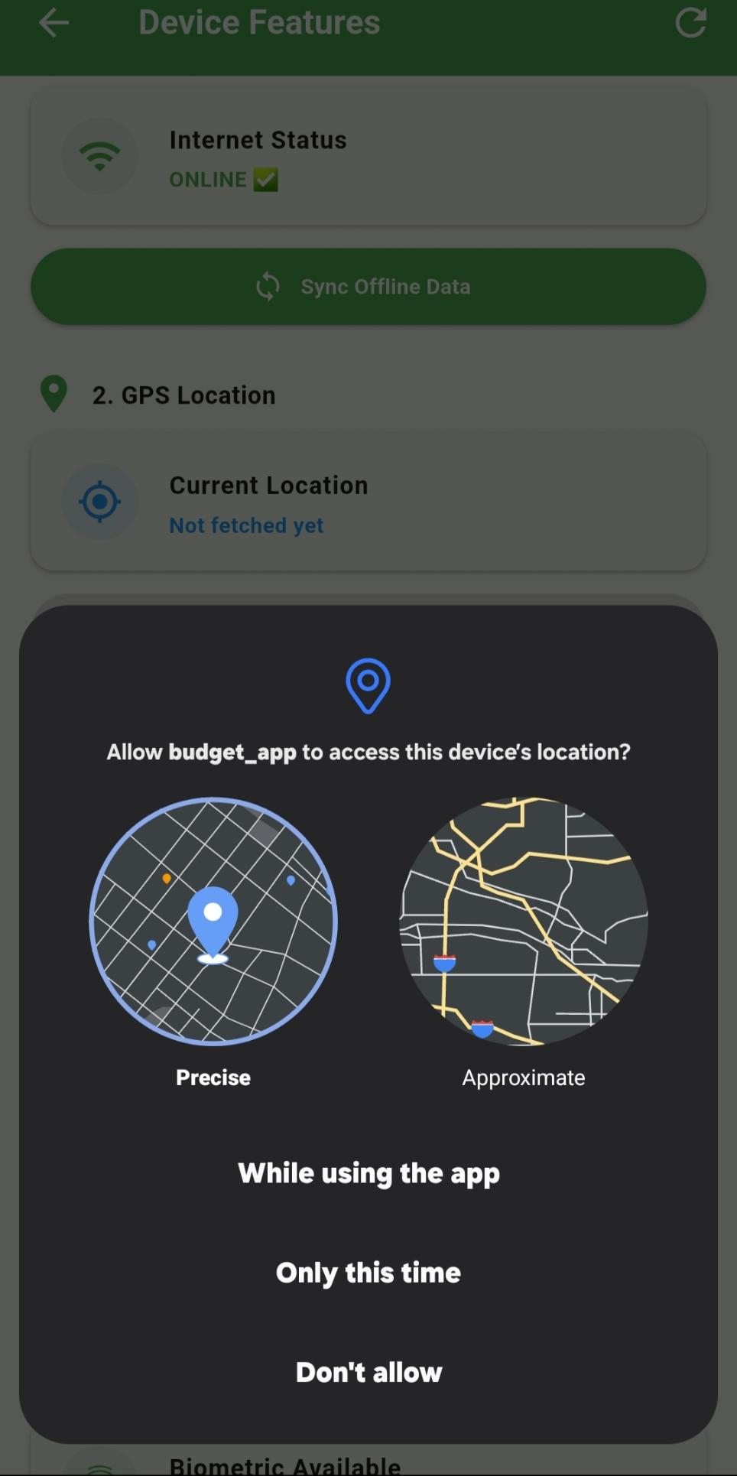

LOCATION LOADING STATE
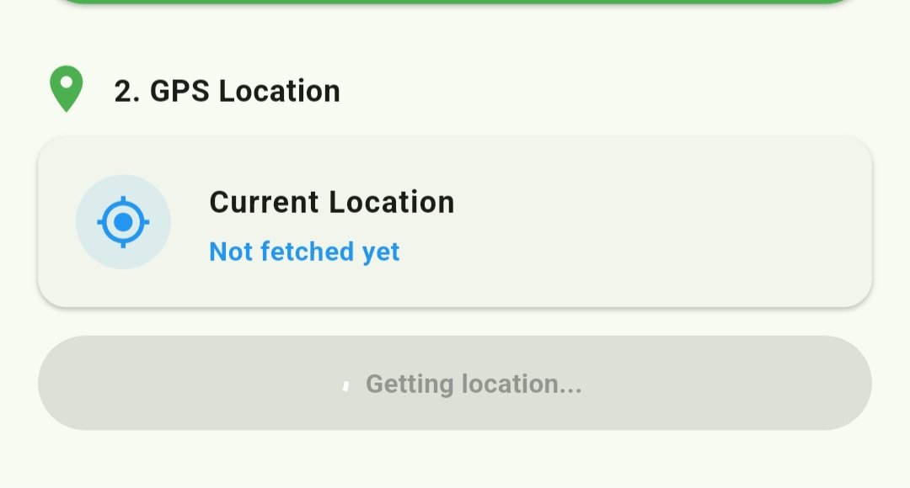

LOCATION SHOWN
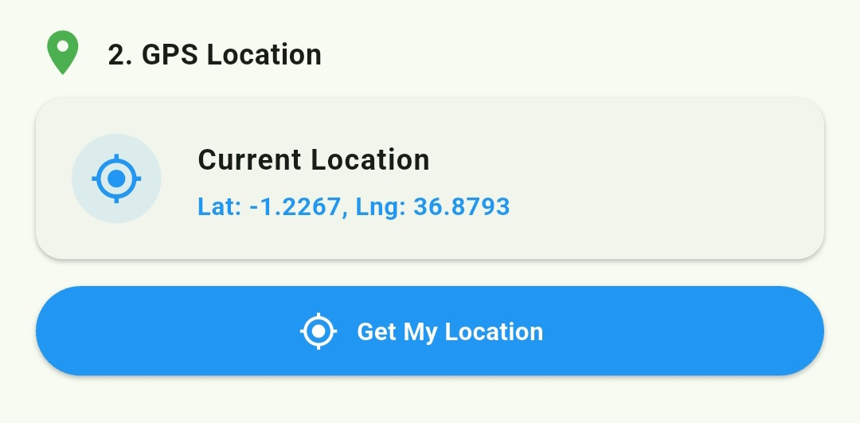

BIOMETRIC SHOWING
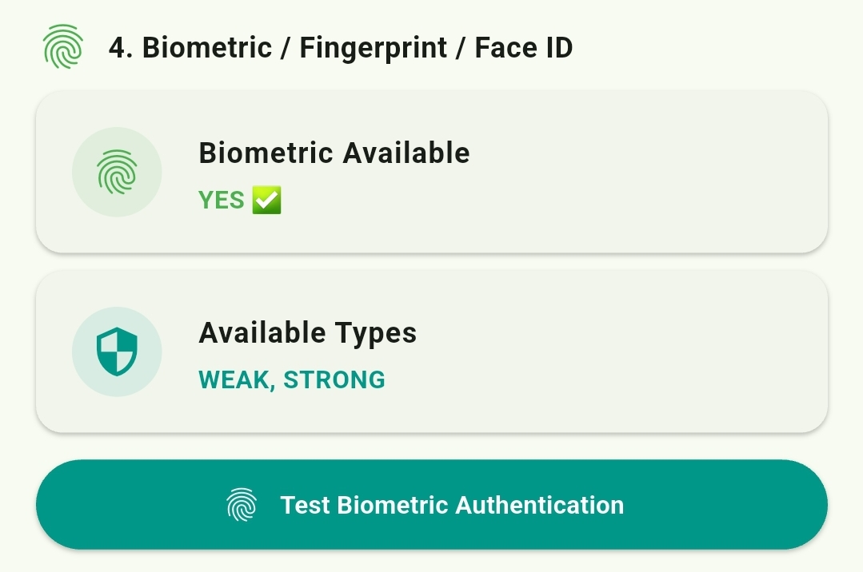

PERSONAL REFLECTION
Integrating device hardware into my budget app was the most exciting week yet. Accessing the camera, retrieving GPS coordinates, and implementing biometric authentication showed me how mobile apps interact with physical hardware. Handling runtime permissions taught me that user privacy and security must always be considered during development.

